2015 Air Quality Updating and Screening Assessment for
South Ayrshire Council

In fulfillment of Part IV of the
Environment Act 1995
Local Air Quality Management

June 2015

Local Authority Officer | Gordon Lauder  Team Leader, Environmental Health  South Ayrshire Council
Department | Development and Environment
Address | 3rd Floor, Burns House, Burns Statue Square, Ayr KA7 1UT
Telephone | 01292 616229 or 01292 618222
e-mail | Gordon.lauder@south-ayrshire.gov.uk
 | environmental.health@southayrshire.gov.uk
Report  Reference number | SAC/USA/2015
Date | June 2015

Executive Summary

South Ayrshire Council has carried out a review of air quality within South Ayrshire which fulfils the requirements of the Local Air Quality Management process as set out in Part IV of the Environment Act (1995), the Air Quality Strategy for England, Scotland, Wales and Northern Ireland 2007 and the report follows technical guidance LAQM.TG(09), (Reference1), issued by the Scottish Executive to assist Local authorities in their Review and Assessment of air quality.

The report forms the Updating and Screening Assessment (USA) of the fourth round of the Review and Assessment process and includes latest available data up to the end of 2011. It also considers the conclusions of the previous rounds of Review and Assessment and any changes that have occurred since then that would have an effect on local air quality.

The report sets out the results of air quality monitoring carried out by South Ayrshire Council and considers the potential impacts from a range of sources such as road traffic and other transport emissions, industrial processes, commercial and domestic fuel use and fugitive emission sources.

The USA concluded that concentrations of the various air quality objectives are unlikely to be exceeded.

A detailed assessment is therefore not required for South Ayrshire Council.
An annual progress report will be submitted to the Scottish Executive by the end of April,2016.
Table of contents
1 Introduction 3
1.1 Description of Local Authority Area 3
1.2 Purpose of Report 3
1.3 Air Quality Objectives 4
1.4 Summary of Previous Review and Assessments 5
2 New Monitoring Data 6
2.1 Summary of Monitoring Undertaken 6
2.1.1 Automatic Monitoring Sites 6
2.1.2 Non-Automatic Monitoring Sites 7
2.2 Comparison of Monitoring Results with AQ Objectives 9
2.2.1 Nitrogen Dioxide 9
2.2.2 PM₁₀ 15
2.2.3 Sulphur Dioxide 17
2.2.4 Benzene 17
2.2.6 Summary of Compliance with AQS Objectives 18
3 Road Traffic Sources 19
3.1 Narrow Congested Streets with Residential Properties Close to the Kerb 19
3.2 Busy Streets Where People May Spend 1-hour or More Close to Traffic 19
3.3 Roads with a High Flow of Buses and/or HGVs. 19
3.4 Junctions 20
3.5 New Roads Constructed or Proposed Since the Last Review and Assessment 20
3.6 Roads with Significantly Changed Traffic Flows 20
3.7 Bus and Coach Stations 20
4 Other Transport Sources 21
4.1 Airports 21
4.2 Railways (Diesel and Steam Trains) 21
4.2.1 Stationary Trains 21
4.2.2 Moving Trains 21
4.3 Ports (Shipping) 22
5 Industrial Sources 23
5.1 Industrial Installations 23
5.1.1 New or Proposed Installations which an Air Quality Assessment has been Carried Out 23
5.1.2 Existing Installations where Emissions have Increased Substantially or New Relevant Exposure has been Introduced 23
5.1.3 New or Significantly Changed Installations with No Previous Air Quality Assessment 23
5.2 Major Fuel (Petrol) Storage Depots 24
5.3 Petrol Stations 24
5.4 Poultry Farms 24
6 Commercial and Domestic Sources 25
6.1 Biomass Combustion – Individual Installations 25
6.2 Biomass Combustion – Combined Impacts 25
6.3 Domestic Solid-Fuel Burning 25
7 Fugitive or Uncontrolled Sources 26
8 Conclusions and Proposed Actions 27
8.1 Conclusions from New Monitoring Data 27
8.2 Conclusions from Assessment of Sources 27
8.3 Proposed Actions 27
9 References 28

List of Tables
Table 1.1 AQ Objectives included in Regulations for the purpose of LAQM in Scotland
Table 1.2 Conclusions Of Previous Rounds Of Review And Assessment

Table 2.1 Details of Automatic Monitoring Sites

Table 2.2 Details of Non- Automatic Monitoring Sites

Table 2.3 Results of Automatic Monitoring of NO₂: Comparison with Annual Mean Objective
Table 2.4 Results of Automatic Monitoring of NO₂: Comparison with 1 Hour Mean Objective Table 2.5 Results of Nitrogen Dioxide Diffusion Tubes in 2014
Table 2.6 Results of Nitrogen Dioxide Diffusion Tubes 2010 – 2014
Table 2.7 Results of PM₁₀ Monitoring: Comparison With Annual Mean Objective
Table 2.8 Results of PM₁₀ Monitoring: Comparison with 24 hour Mean Objective

List of Figures
Figure 1 Location of South Ayrshire
Figure 2 Map of South Ayrshire
Figure 3 Location of High St Ayr air monitoring station
Figure 4 Location of Taylor St Ayr monitoring station

Appendices
Appendix A QA/QC Data
Appendix B Automatic Monitoring Results
Appendix C Full Diffusion tube monitoring data

Introduction

Description of Local Authority Area

South Ayrshire Council is situated to the south-west of Scotland, on the coast of the mouth of the Firth of Clyde and the Irish Sea. The eastern boundary of the council area lies approximately 30 kilometres inland.

South Ayrshire is neighboured by East Ayrshire to the east, North Ayrshire to the north and Dumfries and Galloway Council to the south.

The main commercial and residential centre of South Ayrshire is Ayr, which is situated on the west coast. The other main populated towns of Prestwick, Troon and Girvan are also situated on the west coast. The inland towns and villages are predominantly small communities, with the exception of Maybole which is a busy town.

The main transportation route within South Ayrshire is the A77. The A77 connects the port of Stranraer, which is in the Dumfries and Galloway Council area to Glasgow. The A77 passes through the main west coast towns and villages from Stranraer to Turnberry at which point it heads inland, through Kirkoswald and Maybole, by-passing the outskirts of Ayr and Prestwick before heading north to Glasgow via Kilmarnock.

Glasgow Prestwick International Airport is situated within South Ayrshire to the outskirts of Ayr and Prestwick. Glasgow Prestwick International Airport serves both international and domestic passenger flights as well as a large amount of freight transportation flights.

A map of the area is included in Figure 2.

Purpose of Report
This report fulfils the requirements of the Local Air Quality Management process as set out in Part IV of the Environment Act (1995), the Air Quality Strategy for England, Scotland, Wales and Northern Ireland 2007 and the relevant Policy and Technical Guidance documents. The LAQM process places an obligation on all local authorities to regularly review and assess air quality in their areas, and to determine whether or not the air quality objectives are likely to be achieved. Where exceedences are considered likely, the local authority must then declare an Air Quality Management Area (AQMA) and prepare an Air Quality Action Plan (AQAP) setting out the measures it intends to put in place in pursuit of the objectives.

The objective of this Updating and Screening Assessment is to identify any matters that have changed which may lead to risk of an air quality objective being exceeded. A checklist approach and screening tools are used to identify significant new sources or changes and whether there is a need for a Detailed Assessment. The USA report should provide an update of any outstanding information requested previously in Review and Assessment reports.

Air Quality Objectives
The air quality objectives applicable to LAQM in Scotland are set out in the Air Quality (Scotland) Regulations 2000 (Scottish SI 2000 No 97), the Air Quality (Scotland) (Amendment) Regulations 2002 (Scottish SI 2002 No 297), and are shown in Table 1.1. This table shows the objectives in units of microgrammes per cubic metre μg/m³ (milligrammes per cubic metre, mg/m³ for carbon monoxide) with the number of exceedences in each year that are permitted (where applicable).

Table 1.1 Air Quality Objectives included in Regulations for the purpose of LAQM in Scotland
Pollutant | Air Quality Objective |  | Date to be achieved by
Pollutant | Concentration | Measured as | Date to be achieved by
Benzene | 16.25 µg/m³ | Running annual mean | 31.12.2003
Benzene | 3.25 µg/m³ | Running annual mean | 31.12.2010
1,3-Butadiene | 2.25 µg/m³ | Running annual mean | 31.12.2003
Carbon monoxide | 10.0 mg/m³ | Running 8-hour mean | 31.12.2003
Lead | 0.5 µg/m³ | Annual mean | 31.12.2004
Lead | 0.25 µg/m³ | Annual mean | 31.12.2008
Nitrogen dioxide | 200 µg/m³ not to be exceeded more than 18 times a year | 1-hour mean | 31.12.2005
Nitrogen dioxide | 40 µg/m³ | Annual mean | 31.12.2005
Particles (PM₁₀) (gravimetric) | 50 µg/m³, not to be exceeded more than 7 times a year | 24-hour mean | 31.12.2010
Particles (PM₁₀) (gravimetric) | 18 µg/m³ | Annual mean | 31.12.2010
Sulphur dioxide | 350 µg/m³, not to be exceeded more than 24 times a year | 1-hour mean | 31.12.2004
Sulphur dioxide | 125 µg/m³, not to be exceeded more than 3 times a year | 24-hour mean | 31.12.2004
Sulphur dioxide | 266 µg/m³, not to be exceeded more than 35 times a year | 15-minute mean | 31.12.2005

Summary of Previous Review and Assessments
Table 1.2 summarises previous rounds of R&A and the exceedences identified or predicted. No AQMA’s have been declared nor are there are any locations where exceedences of objective concentrations have previously been identified but reports have judged that no AQMA is necessary. Finally no AQMA’s have been revoked.

Table 1.2 Conclusions Of Previous Rounds Of Review And Assessment

Date & Title Of Report Produced  By South Ayrshire |  | Brief Outcome
April 2000 | Stage 1 Review and Assessment | No exceedences of air quality objectives
June 2003 | 2003 Updating and Screening Assessment Report | No exceedences of air quality objectives however PM₁₀ levels in Dailly village predicted to be high to due to high density of domestic coal burning properties. Requested to proceed with a detailed assessment
June 2004 | 2004 Detailed Assessment PM₁₀ levels in Dailly village | No exceedences of PM₁₀ levels in Dailly village
April 2005 | 2005 Progress Report | No exceedences of air quality objectives
April 2006 | 2006 Updating and Screening Assessment report | No exceedences of air quality objectives however PM₁₀ levels in Ayr town Centre predicted at being near objective limit. Requested to proceed with a detailed assessment.
August 2007 | 2007 Detailed Assessment  PM₁₀ levels in Ayr town centre | No exceedences of PM₁₀ levels in Ayr town centre
April 2008 | 2008 Progress Report | No exceedences of air quality objectives
April 2009 | 2009 Updating and Screening Assessment Report | No exceedences of air quality objectives
April 2010 | 2010 Progress Report | No exceedences of air quality objectives
April 2011 | 2011 Progress report | No exceedences of air quality objectives
April 2012 | 2012 Updating and Screening Assessment Report | No exceedences of air quality objectives
April 2013 | 2013 Progress report | No exceedences of air quality objectives
April 2014 | 2014 Progress report | No exceedences of air quality objectives

New Monitoring Data

Summary of Monitoring Undertaken

Automatic Monitoring Sites
South Ayrshire Council operates two automatic monitoring stations. Both stations are fitted with a real l time Chemiluminescent NOX analyser and a TEOM PM10 monitor fitted with FDMS. Both monitors are fitted with web logger functionality.

One station is located in Ayr town centre at the junction of High Street and New Bridge Street and the other station is located at the corner of Taylor Street and York Street Ayr.

Further details of the monitoring stations are provided in Table 2.1. The locations of monitoring stations are shown in Figures 1 and 2, respectively.

Table 2.1 Details of Automatic Monitoring Sites
Site Name | Site Type | OS Grid Ref | Pollutants Monitored | In AQMA? | Relevant  Exposure? (Y/N with dist-ance (m) to relevant exposure) | Distance to kerb of near-est road  (N/A if not applicable) | Worst-case Location?
High St Ayr | Kerb-side | X 337223  Y 221162 | NO₂  PM₁₀ | N | Y (5m) | 2m | Y
Taylor St (Harbour) Ayr | Kerb-side | X233608  Y622750 | NO₂  PM₁₀ | N | Y (10m) | 1m | Y

The maintenance of the two monitoring stations is carried out by Air Monitors. This involves two routine services per year and also provision for emergency callouts. Automatic calibration and span checks are carried out daily.

Both sites are part of the Scottish Air Quality network and are audited by Ricardo AEA. They also carry out the data management for this site. The data is checked to ensure that it is being recorded correctly, the analysers are stable and there are no faults with the analysers. The data is then re-scaled using the results of the calibration and span checks which are carried out automatically by the analyser.

PM₁₀ is measured at both monitoring stations using TEOM FDMS units. Since both units are fitted with FDMS there is no need to apply a correction factor to the recorded result.

Non-Automatic Monitoring Sites

Monitoring of nitrogen dioxide was undertaken using passive diffusion tubes at 20 separate locations in South Ayrshire during 2014.The diffusion tube locations are described in Table 2.2.

Monitoring of benzene is no longer undertaken by south Ayrshire council due to previous years monitoring only yielding very low results.

Table 2.2 Details of Non- Automatic Monitoring Sites
Site Name | Site Type | OS Grid Ref | Pollutants Monitored | In AQMA? | Relevant  Exposure? (Y/N with distance (m) to relevant exposure) | Distance to kerb of nearest road  (N/A if not applicable) | Worst-case Lo-cation?
1. 30 Main Street Loans (across from garage) | Roadside | X234529  Y631708 | NO₂ | N | 10m | 2m | Y
2. Dundonald Road Traffic lights, Troon | Roadside | X 232588  Y 631277 | NO₂ | N | 10m | 2m | Y
3. Farmfoods 2 Portland St Troon | Roadside | X232292  Y631235 | NO₂ | N | 10m | 2m | Y
4. Shaw Farm Gardens Prestwick | Roadside | X 235622  Y 626548 | NO₂ | N | 5m | 1m | Y
5. The Eagle, 3 the Cross Prestwick | Roadside | X235229  Y626228 | NO₂ | N | 5m | 2m | Y
6. Taj, 141 Main St Prestwick | Roadside | X235142  Y625816 | NO₂ | N | 2m | 2m | Y
07. Heathfield Rd/Prestwick Rd Ayr | Roadside | X 234641  Y624159 | NO₂ | N | 2m | 1m | Y
08. Station Taxi Rank, Ayr | Roadside | X 240194  Y 624754 | NO₂ | N | 5m | 1m | Y
09. Morrisons, Castlehill Rd Ayr | Roadside | X 232153  Y 621149 | NO₂ | N | 5m | 2m | Y
10. 39 Whitletts Road, Ayr | Roadside | X 234605  Y 622412 | NO₂ | N | 2m | N/A | Y
11. Tesco Whitletts Rd Ayr | Roadside | X 235150  Y 622528 | NO₂ | N | 10m | 2m | Y
12. King St. (cctv pole), Ayr | Roadside | X233830  Y 622352 | NO₂ | N | 2m | 1m | Y
13. Town Buildings Ayr | Roadside | X233691  Y 622093 | NO₂ | N | 2m | 2m | Y
14. 1 AQ Station, Ayr (N facing) | Roadside | X 233701  Y 622114 | NO₂ | N | 5m | 2m | Y
15. 2 AQ Station, Ayr (W facing) | Roadside | X 233701  Y 622114 | NO₂ | N | 5m | 2m | Y
16. 3 AQ Station, Ayr (S facing) | Roadside | X 233701  Y 622114 | NO₂ | N | 10m | 2m | Y
17. Rozelle Park Ayr | Urban background | X 233763  Y 618944 | NO₂ | N | 10m | N/A | N
18. Minishant Inn (across rd) | Roadside | X 232983  Y 614277 | NO₂ | N | 10m | 1m | Y
19. Post Office Maybole | Roadside | X 230110  Y 609984 | NO₂ | N | 10m | 1m | Y
20. Roxy, Bridge St Girvan | Roadside | X 281549  Y 598064 | NO₂ | N | 5m | 1m | Y

The nitrogen dioxide diffusion tubes are placed at each location by South Ayrshire Council for a period of approximately one month. At the end of each monthly period, the exposed tubes are replaced with new tubes and the exposed tubes are sent to the laboratory for analysis. Laboratory analysis of the passive diffusion tubes is undertaken by Glasgow Scientific Services (GSS) - part of the City of Glasgow Council. The laboratory is UKAS accredited for the analysis.

GSS prepares the diffusion tubes using the technique of 20% TEA in water.
The laboratory undertakes the analysis of diffusion tubes from Glasgow City Council, which undertakes an annual co-location study of diffusion tubes from automatic monitoring stations in the city for the purposes of validation.

GSS follow the procedures set out in the harmonisation panel guidance and participate in the AEA Technology laboratory inter -comparison scheme and scored a 100% result for accuracy in the WASP scheme for analysis of NO2 diffusion tubes during the whole of 2014.

The scheme whilst assessing the analytical performance of laboratories, also allows for the performance of the laboratory against chemiluminescence techniques to be determined.
A laboratory bias for GSS was therefore determined using the methodology contained in the LAQM technical guidance document LAQM TG(09)
The bias factor was determined utilising the excel spreadsheet from the review and assessment helpdesk website (Reference 2) the bias factor was calculated for GSS in 2014 at 0.83 and was applied to all sites.

Comparison of Monitoring Results with AQ Objectives

This section sets out the results of all the monitoring carried out by South Ayrshire Council in 2014 and where relevant, provides results from previous years to identify any trends.

Nitrogen Dioxide

Automatic Monitoring Data
The results of the automatic monitoring for Nitrogen Dioxide carried out in 2014 at High Street / New Bridge Street Ayr and York Street/Taylor St Ayr are displayed in Tables 2.3 and 2.4

Table 2.3 Results of Automatic Monitoring of Nitrogen Dioxide: Comparison with Annual Mean Objective

Site ID | Location | Site Type | Within AQMA? | Valid Data Capture for period of monitoring %ª | Valid Data Capture 2014 % ^{b} | Annual Mean Concentration μg/m³
 |  |  |  |  |  | 2010*^{c} | 2011* ^{c} | 2012* ^{c} | 2013* ^{c} | 2014 ^{c}
A1 | High St Ayr | Roadside | N | 92.9 | 92.9 | 24 | 9 | 20 | 23 | 17
A2 | Taylor St Ayr | Roadside | N | 97.0 | 97.0 | N/A | N/A | 15* | 14 | 9

ª i.e. data capture for the monitoring period, in cases where monitoring was only carried out for part of the year.
^{b} i.e. data capture for the full calendar year (e.g. if monitoring was carried out for six months the maximum data capture for the full calendar year would be 50%).
^{c} Means should be “annualised” as in Box 3.2 of TG(09), if monitoring was not carried out for the full year.
*Annual mean concentrations for previous years are optional.

Chart 1: Annual Mean NO₂ (µg/m³) from Automatic Monitoring Stations

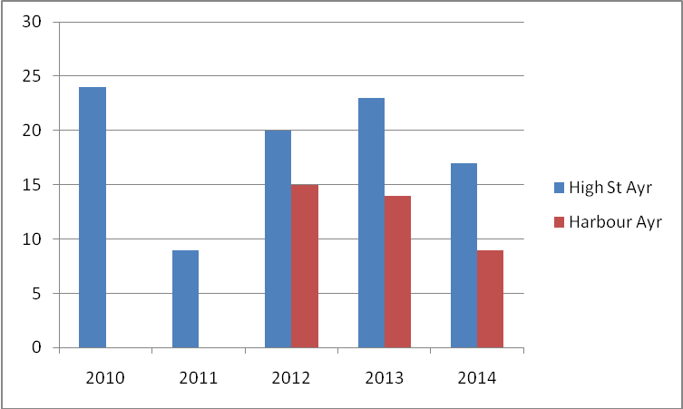

Chart 2 shows annual mean NO₂ (µg/m³) at High St, Ayr from 2010 to 2014 and for Ayr harbour 2012- 2014
Annual mean NO₂Levels at Ayr High Street rose dropped significantly in 2011, rose slightly 2012 and 2013 and then dropped in 2014. The reason for this is unknown. Conversely, levels at Ayr Harbour have gradually reducede since monitoring commenced in 2012

Table 2.4 Results of Automatic Monitoring for Nitrogen Dioxide: Comparison with 1-hour Mean Objective
Site ID | Location | Site Type | Within AQMA? | Valid Data Capture for period of monitoring %ª | Valid Data Capture 2014 % ^{b} | Number of Exceedences of Hourly Mean (200 μg/m³)
 |  |  |  |  |  | 2010*^{c} | 2011* ^{c} | 2012* ^{c} | 2013* ^{c} | 2014 ^{c}
A1 | High St Ayr | Road-  side | No | 92.9 | 92.9 | 0 | 0 | 0  (88) | 0  (88) | 0
A2 | Taylor St Ayr | Road-  side | No | 97.0 | 97.0 | N/A | N/A | 0  (50) | 0  (50) | 0
ª i.e. data capture for the monitoring period, in cases where monitoring was only carried out for part of the year.
^{b} i.e. data capture for the full calendar year (e.g. if monitoring was carried out for six months the maximum data capture for the full calendar year would be 50%.)
^{c} If the period of valid data is less than 90%, include the 99.8th percentile of hourly means in brackets

Diffusion Tube Monitoring Data
The bias adjustment factor of 0.83 was obtained from the spreadsheet located on the Scottish Air Quality website. The 0.83 bias adjustment was applied to all NO₂ diffusion tube results.

All diffusion tubes were below the objective limit of 40 μg/m³

Table 2.5 Results of Nitrogen Dioxide Diffusion Tubes in 2014
Site ID | Location | Site Type | Within AQMA? | Triplicate or Collocated Tube | Data  Capture  2014  %) | Data with less than 9 months has been annualised (Y/N) | Confirm if data has been dist-ance corrected (Y/N) | Annual mean concentration  (Bias Adjustment factor = 0.83)
 |  |  |  |  |  |  |  | 2014 (μg/m³)
N1 | 30 Main St Loans | Roadside | N | N | 100 | N | N | 9
N2 | Co-Op Dundonald Rd Troon | Woodland | N | N | 100 | N | N | 13
N3 | Farmfoods, 2 Portland St Troon | Roadside | N | N | 100 | N | N | 16
N4 | Shawfarm Gardens Prestwick | Roadside | N | N | 100 | N | N | 12
N5 | The Eagle, 3 The Cross Prestwick | Roadside | N | N | 92 | N | N | 24
N6 | Taj Restaurant, 141 main Street Prestwick | Roadside | N | N | 92 | N | N | 20
N7 | Heathfield Rd/ Prestwick Rd | Roadside | N | N | 92 | N | N | 26
N8 | Station Taxi Rank Ayr | Roadside | N | N | 92 | N | N | 19
N9 | Morrisons Ayr | Roadside | N | N | 100 | N | N | 19
N10 | 39 Whitletts Rd Ayr | Roadside | N | N | 92 | N | N | 24
N11 | Tesco Ayr | Roadside | N | N | 100 | N | N | 24
N12 | King St (CCTV pole) Ayr | Roadside | N | N | 92 | N | N | 31
N13 | Town Buildings Ayr | Roadside | N | Y | 100 | N | N | 29
N14 | 1AQ Station Ayr North | Roadside | N | N | 92 | N | N | 15
N15 | 2 AQ Station Ayr West | Roadside | N | N | 92 | N | N | 14
N16 | 3 AQ Station Ayr South | Roadside | N | N | 100 | N | N | 14
N17 | Rozelle Park , Alloway | Roadside | N | N | 100 | N | N | 14
N18 | Minishant Inn (across rd) | Roadside | N | N | 100 | Y | N | 16
N19 | Post Office Maybole | Roadside | N | Y | 83 | N | N | 23
N20 | Roxy bar Bridge St Girvan | Roadside | N | N | 83 | N | N | 24

Table 2.6 Results of Nitrogen Dioxide Diffusion Tubes (2010 to 2014)

Site ID | Site Address | Site Type | Within AQMA? | Annual mean concentration (adjusted for bias) μg/m³
 |  |  |  | 2010*  (Bias Adjustment Factor = 1.1) | 2011*  (Bias Adjustment Factor = 0.94) | 2012*  (Bias Adjustment Factor = 0.95) | 2013*  (Bias Adjustment Factor = 0.99) | 2014  (Bias Adjustment Factor = 0.83)
N1 | 30 Main Street Loans | Roadside | N | x | x | x | x | 9
N2 | Co-op Dundonald Road, Troon | Roadside | N | 22 | 23 | 24 | 25 | 13
N3 | Farmfoods, 2 Portland St Troon | Roadside | N | x | x | x | x | 16
N4 | Shaw Farm Gardens Prestwick | Roadside | N | 21 | 21 | 15 | 15 | 12
N5 | The Eagle 3 The Cross Prestwick | Roadside | N | x | x | x | x | 24
N6 | Taj, 141 Main St Prestwick | Roadside | N | x | x | x | x | 20
N7 | Heathfield Rd/Prestwick Road Ayr | Roadside | N | 38 | 36 | 31 | 35 | 26
N8 | Station Taxi Rank, Ayr | Roadside | N | 30 | 31 | 18 | 22 | 19
N9 | Morrisons, Castlehill Rd  Ayr | Roadside | N | * | * | * | 15 | 19
N10 | 39 Whitletts Road, Ayr | Roadside | N | 40 | 39 | 29 | 31 | 24
N11 | Tesco. Whitletts road Ayr | Roadside | N | 32 | 31 | 29 | 26 | 24
N12 | King Street,  Ayr | Roadside | N | 53 | 53 | 39 | 38 | 31
N13 | Town Buildings, Ayr | Roadside | N | 42 | 45 | 33 | 36 | 29
N14 | 1 AQ Station, Ayr (North facing) | Roadside | N | * | * | 17 | 16 | 15
N15 | 2 AQ Station, Ayr (West facing) | Roadside | N | * | * | 18 | 20 | 14
N16 | 3 AQ Station, Ayr (South facing) | Roadside | N | 40 | 39 | 29 | 31 | 14
N17 | Rozelle Park,  Ayr | Woodland | N | 7 | 9 | 4 | 5 | 4
N18 | Minishant Inn, Main St Minishant | Roadside | N | x | x | x | x | 16
N19 | Post office High St Maybole | Roadside | N | x | x | x | x | 23
N20 | Roxy Bar, Bridge Street, Girvan | Roadside | N | 36 | 37 | 24 | 25 | 24

Chart 2 Trends in Annual Mean Nitrogen Dioxide Concentrations (μg/m³⁾ measured at Diffusion Tube Monitoring Sites

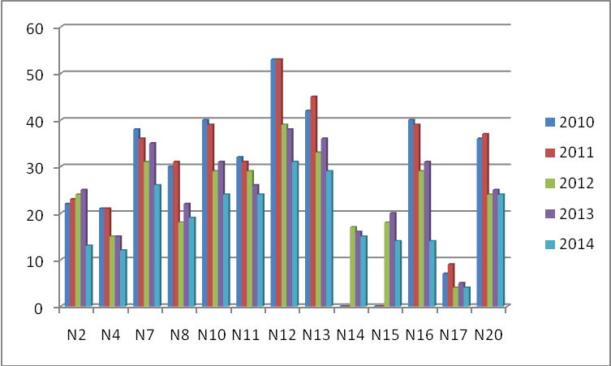

The majority of the tubes appear to show a slight increase from 2010 to 2011 and a marked decrease from 2012 to 2014. Part of the reason for the particularly large reduction in 2014 may have been as a result of the bias correction factor being lower at 0.83 compared to 0.99 in 2013.

PM₁₀

Results of PM₁₀ Automatic Monitoring obtained from TEOM’s fitted with FDMS and web logger functionality at High Street/New Bridge St Ayr and Taylor St/York St Ayr are displayed in Table 2.5a and 2.5b. Collected data did not show any exceedences of either annual mean or 24-hour mean PM₁₀ objectives in 2014

South Ayrshire Council previously monitored PM₁₀ at New Bridge Street Ayr using a tapered element oscillated microbalance (TEOM) analyser. The results from this were reported in the detailed assessment, which was submitted in September 2007. The conclusions of that report were that it was unlikely that there would be in exceedence of either annual mean or 24-hour mean PM₁₀ objectives in 2010 however further monitoring should be carried out.

Table 2.7 Results of Automatic Monitoring of PM₁₀: Comparison with Annual Mean Objective
Site ID | Site Type | Within AQMA? | Valid Data Capture for monitoring Period %ª | Valid Data Capture 2014 %^{b} | Confirm Gravimetric Equivalent  (Y or NA) | Annual Mean Concentration μg/m³
 |  |  |  |  |  | 2010*^{c} | 2011* ^{c} | 2012* ^{c} | 2013* ^{c} | 2014 ^{c}
A1 High St Ayr | Roadside | N | 80.7 | 80.7 | N/A | 16 | 13 | 13 | 15 | 14
A2 Taylor St (Harbour) Ayr | Roadside | N | 80.7 | 80.7 | N/A | N/A | N/A | 13* | 17 | 13
ª i.e. data capture for the monitoring period, in cases where monitoring was only carried out for part of the year.
^{b} i.e. data capture for the full calendar year (e.g. if monitoring was carried out for six months the maximum data capture for the full calendar year would be 50%.)
^{c} Means should be “annualised” as in Box 3.2 of TG(09), if monitoring was not carried out for the full year.
* Optional

Chart 3 Trends in Annual Mean PM₁₀ Concentrations (μg/m³)
.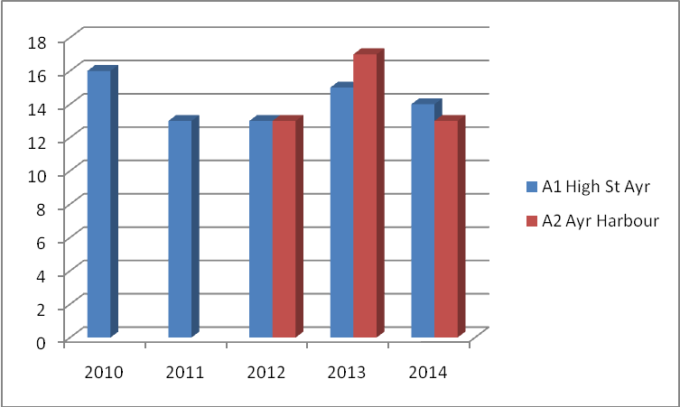

Figure 2.5 displays the annual mean PM₁₀ levels at High St Ayr 2010 – 2014 and Ayr Harbour 2012 - 2014. Levels appear to have decreased gradually from 2010 to 2012, increased in 2013 then decreased again in 2014. The reason for these fluctuations are unknown.

Table 2.8 Results of Automatic Monitoring for PM₁₀: Comparison with 24-hour mean Objective

Site ID | Site Type | Within AQMA? | Valid Data Capture for monitoring Period %ª | Valid Data Capture 2014 %^{b} | Confirm Gravimetric Equivalent | Number of Exceedences of 24-Hour Mean (50 μg/m³)
 |  |  |  |  |  | 2010* | 2011* | 2012* | 2013* | 2014
A1 High St Ayr | Roadside | N | 80.7 | 80.7 | N/A | 0 | 0 | 3  (35) | 2  (34) | 0
A2 Taylor St Ayr | Roadside | N | 84.5 | 84.5 | N/A | N/A | N/A | 0  (29) | 1  (38) | 0

ª i.e. data capture for the monitoring period, in cases where monitoring was only carried out for part of the year.
^{b} i.e. data capture for the full calendar year (e.g. if monitoring was carried out for six months the maximum data capture for the full calendar year would be 50%.)
^{c} if data capture is less than 90%, include the 90th percentile of 24-hour means in brackets
* Optional

There were no exceedences of the 24-hour mean objective at either site in 2014. This is a distinct improvement form 2012 and 2013 as both those years showed a total of 3 exceedences totalled across both sites.

Sulphur Dioxide
No Sulphur Dioxide monitoring was carried out in South Ayrshire in 2010.

Previously monitoring was by means of two eight port bubblers, one at Dundonald Activity Centre and the other at the Road Depot within Grangeston Industrial Estate Girvan. Analysis of the solution took place at Glasgow Scientific Services.

Monitoring ceased at Dundonald at the end of 2006 and at Girvan at the end of 2007.

The results of that monitoring indicated that there would be no exceedences of the objective standard as was reported in South Ayrshire Council’s 2008 Progress Report.

Benzene
Benzene monitoring has not been carried out in South Ayrshire since 2008. The results of that monitoring indicated that there would be no exceedances of the objective standard as was reported in South Ayrshire Council’s 2009 Updating and Screening Assessment.

Summary of Compliance with AQS Objectives

South Ayrshire Council has examined the results from monitoring in the district.

Concentrations are all below the objectives, therefore there is no need to proceed to a Detailed Assessment.

Road Traffic Sources

Narrow Congested Streets with Residential Properties Close to the Kerb
In order to provide an assessment of road traffic sources for this report, the most up to date information on traffic flows on several roads within South Ayrshire was obtained from the Roads section at South Ayrshire Council and Transport Scotland. The updated traffic information is shown in Appendix

The towns of Ayr and Maybole were identified as areas where there are narrow congested streets with residential properties within 5m of the kerb. Both areas were assessed in previous rounds of review and assessment and do not require further consideration.

South Ayrshire Council confirms that there are no new/newly identified congested streets with a flow above 5,000 vehicles per day and residential properties close to the kerb, that have not been adequately considered in previous rounds of Review and Assessment.

Busy Streets Where People May Spend 1-hour or More Close to Traffic
The busy streets of Ayr and Maybole were assessed at previous rounds of review and assessment.

South Ayrshire Council confirms that there are no new/newly identified busy streets where people may spend 1 hour or more close to traffic.

Roads with a High Flow of Buses and/or HGVs.
Roads with a high flow of buses and/or HGV’s were assessed at previous rounds of review and assessment.

South Ayrshire Council confirms that there are no new/newly identified roads with high flows of buses/HDVs.

Junctions
Busy roads and junctions (greater than 5,000 vehicles per day) with relevant exposure in South Ayrshire were assessed in previous rounds of review and assessment.

South Ayrshire Council confirms that there are no new/newly identified busy junctions/busy roads.

New Roads Constructed or Proposed Since the Last Round of Review and Assessment

No new roads with relevant exposure have been constructed in South Ayrshire since last round of review and assessment.

South Ayrshire Council confirms that there are no new/proposed roads.

Roads with Significantly Changed Traffic Flows
South Ayrshire Council confirms that there are no new/newly identified roads with significantly changed traffic flows.

Bus and Coach Stations
There is only one bus station within South Ayrshire and that is situated off Fullarton Street in Ayr however there is less than 2,500 movements per day.

South Ayrshire Council confirms that there are no relevant bus stations in the Local Authority area.

Other Transport Sources

Airports
There is one airport situated within South Ayrshire – namely Prestwick however the total equivalent passenger numbers in million passengers per annum (mppa) is less than 10. Likewise, the background NOx concentration is less than 25 µg/m³

South Ayrshire Council confirms that there are no relevant airports in the Local Authority area.

Railways (Diesel and Steam Trains)
The main Ayr – Glasgow passenger line passing through South Ayrshire is electrified. Freight trains are much fewer in number and are diesel powered. There are currently no steam trains operating within South Ayrshire.

Stationary Trains
The only rail yard within South Ayrshire where diesel trains are stationary for more than 15 minutes is Falkland Junction in Ayr however there are no potential for relevant exposure within 15m.

South Ayrshire Council confirms that there are no locations where diesel or steam trains are regularly stationary for periods of 15 minutes or more, with potential for relevant exposure within 15m.

Moving Trains

South Ayrshire Council confirms that there are no locations with a large number of movements of diesel locomotives, and potential long-term relevant exposure within 30m.

Ports (Shipping)
Troon Harbour previously operated a roll on –roll off ferry to Belfast once per day throughout the year however this service has now ceased. A fast ferry (Seacat) still operates twice per day to Belfast for 6 months during the summer months. In addition last year Troon saw 208 movements of cargo ships carrying logs. This totals at 725 movements for 2014.

Ayr Harbour saw a total of 335 cargo ship movements in 2014.

(This information was supplied by Mr Stuart Creswell, of Associated British Ports)

South Ayrshire Council confirms that there are no ports or shipping that meet the specified criteria within the Local Authority area.

Industrial Sources

Industrial Installations
Information on installations regulated under the Pollution Prevention and Control (Scotland) Regulations 2000 as either Part A or Part b processes was obtained from SEPA. The list of authorised processes is set out in Appendix 3.

New or Proposed Installations for which an Air Quality Assessment has been Carried Out
Information on any new or proposed installations for which an air quality assessment has been carried out was obtained from SEPA.

South Ayrshire Council confirms that there are no new or proposed industrial installations for which planning approval has been granted within its area or nearby in a neighbouring authority.

Existing Installations where Emissions have Increased Substantially or New Relevant Exposure has been Introduced
Information obtained from SEPA indicates that there are no existing industrial installations where emissions have substantially increased.

South Ayrshire Council confirms that there are no industrial installations with substantially increased emissions or new relevant exposure in their vicinity within its area or nearby in a neighbouring authority.

New or Significantly Changed Installations with No Previous Air Quality Assessment
Information obtained from SEPA indicates that there are no new or significantly changed installations with no previous air quality assessment.

South Ayrshire Council confirms that there are no new or proposed industrial installations for which planning approval has been granted within its area or nearby in a neighbouring authority.

Major Fuel (Petrol) Storage Depots

According to Appendix E of LAQM TG(09) and information from SEPA, there are no major fuel storage depots within South Ayrshire

There are no major fuel (petrol) storage depots within the Local Authority area.

Petrol Stations

A survey of all major petrol stations in the area did not reveal any where there was relevant exposure within 10m of the pumps.

South Ayrshire Council confirms that there are no petrol stations meeting the specified criteria.

Poultry Farms

There are only three known poultry farms in South Ayrshire as follows;

- Auchincruive Agricultural College by Ayr which houses a maximum of 35,000 chickens and a few hundred turkeys part of the year.

- Auld Byres Farm, by Coylton which houses a maximum of 16,000 chickens.

- Brochniel Farm, by Girvan which houses a maximum of 3,000 chickens.

(This information was supplied by the Animal Health Division, Agriculture, Environment and Fisheries Department, Russell House, Ayr)

South Ayrshire Council confirms that there are no poultry farms meeting the specified criteria.

Commercial and Domestic Sources

Biomass Combustion – Individual Installations

South Ayrshire Council has previously assessed the biomass combustion plant, and concluded that it will not be necessary to proceed to a Detailed Assessment.

Biomass Combustion – Combined Impacts

South Ayrshire Council has assessed the biomass combustion plant, and concluded that it will not be necessary to proceed to a Detailed Assessment.

Domestic Solid-Fuel Burning
Domestic properties burning solid fuel was assessed in previous rounds of review and assessment and it was found that in two areas the number of residential properties exceeded 100 per 500m square area. These were the villages of Dailly and Tarbolton. Pm₁₀ and No₂ monitoring at those areas did not show any exceedance of the relevant air quality objective standard. No further assessment of residential properties burning solid fuel is required.

South Ayrshire Council has assessed areas of significant domestic solid fuel use, and concluded that it will not be necessary to proceed to a Detailed Assessment.

Fugitive or Uncontrolled Sources

There are no new fugitive sources since the previous Upgrading and Screening Assessment in 2012.

There have been no complaints of dust from existing quarries or landfills.

South Ayrshire Council confirms that there are no potential sources of fugitive particulate matter emissions in the Local Authority area.

Conclusions and Proposed Actions

Conclusions from New Monitoring Data
Continuous monitoring of Nox and PM₁₀ levels at High Street Ayr and Taylor Street Ayr did not show any exceedences of the relevant air quality objectives.

Likewise, diffusion tube monitoring of Nox throughout the district did not reveal any exceeedences of the relevant air quality objectives.

All new monitoring data is within the air quality objectives.

Conclusions from Assessment of Sources
Road Traffic Sources

The Updating and Screening Assessment did not identify the need for a Detailed Assessment in respect of nitrogen dioxide or PM₁₀.

Other Transport Sources

No issues were identified in relation to the other transport sources.

Industrial Sources

No issues were identified in relation to industrial sources.

Commercial and Domestic Sources

No issues were identified in relation to commercial and domestic sources. Assessment of the proposed biomass plant at the proposed community hospital will be carried out in future LAQM assessments.

Fugitive and Uncontrolled Sources

No issues were identified in relation to fugitive and uncontrolled sources

Proposed Actions
South Ayrshire Council’s Updating and Screening Assessment for 2015 identified no exceedences of the air quality objectives and we will therefore not be proceeding with a detailed assessment.

A Progress Report will be submitted in 2016

References

- Defra and the Devolved Administrations, Local Air Quality Management, Technical Guidance LAQM.TG (09), February 2009.
- Defra and the Devolved Administrations, Spreadsheet of Bias Adjustment Factors, version 03/15, accessed at: http://laqm.defra.gov.uk/documents/Database_Diffusion_Tube_Bias_Factors-v03_15-Final.xls

Figures
Figure 1: Location of South Ayrshire

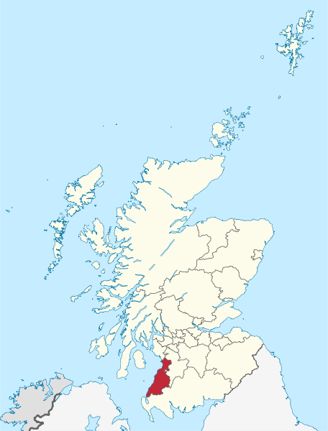

Figure 2: Map Of South Ayrshire District

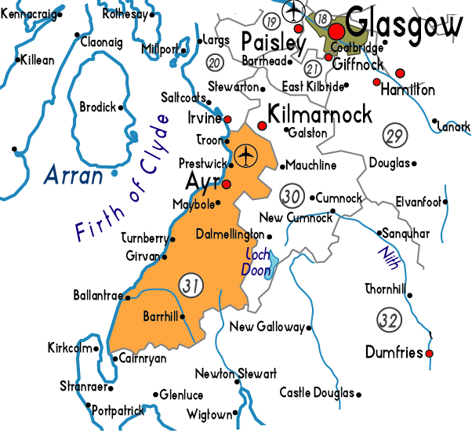

Figure 3: Location of Ayr High Street Monitoring Station

Figure 4: Location of Taylor Street Ayr Monitoring Station

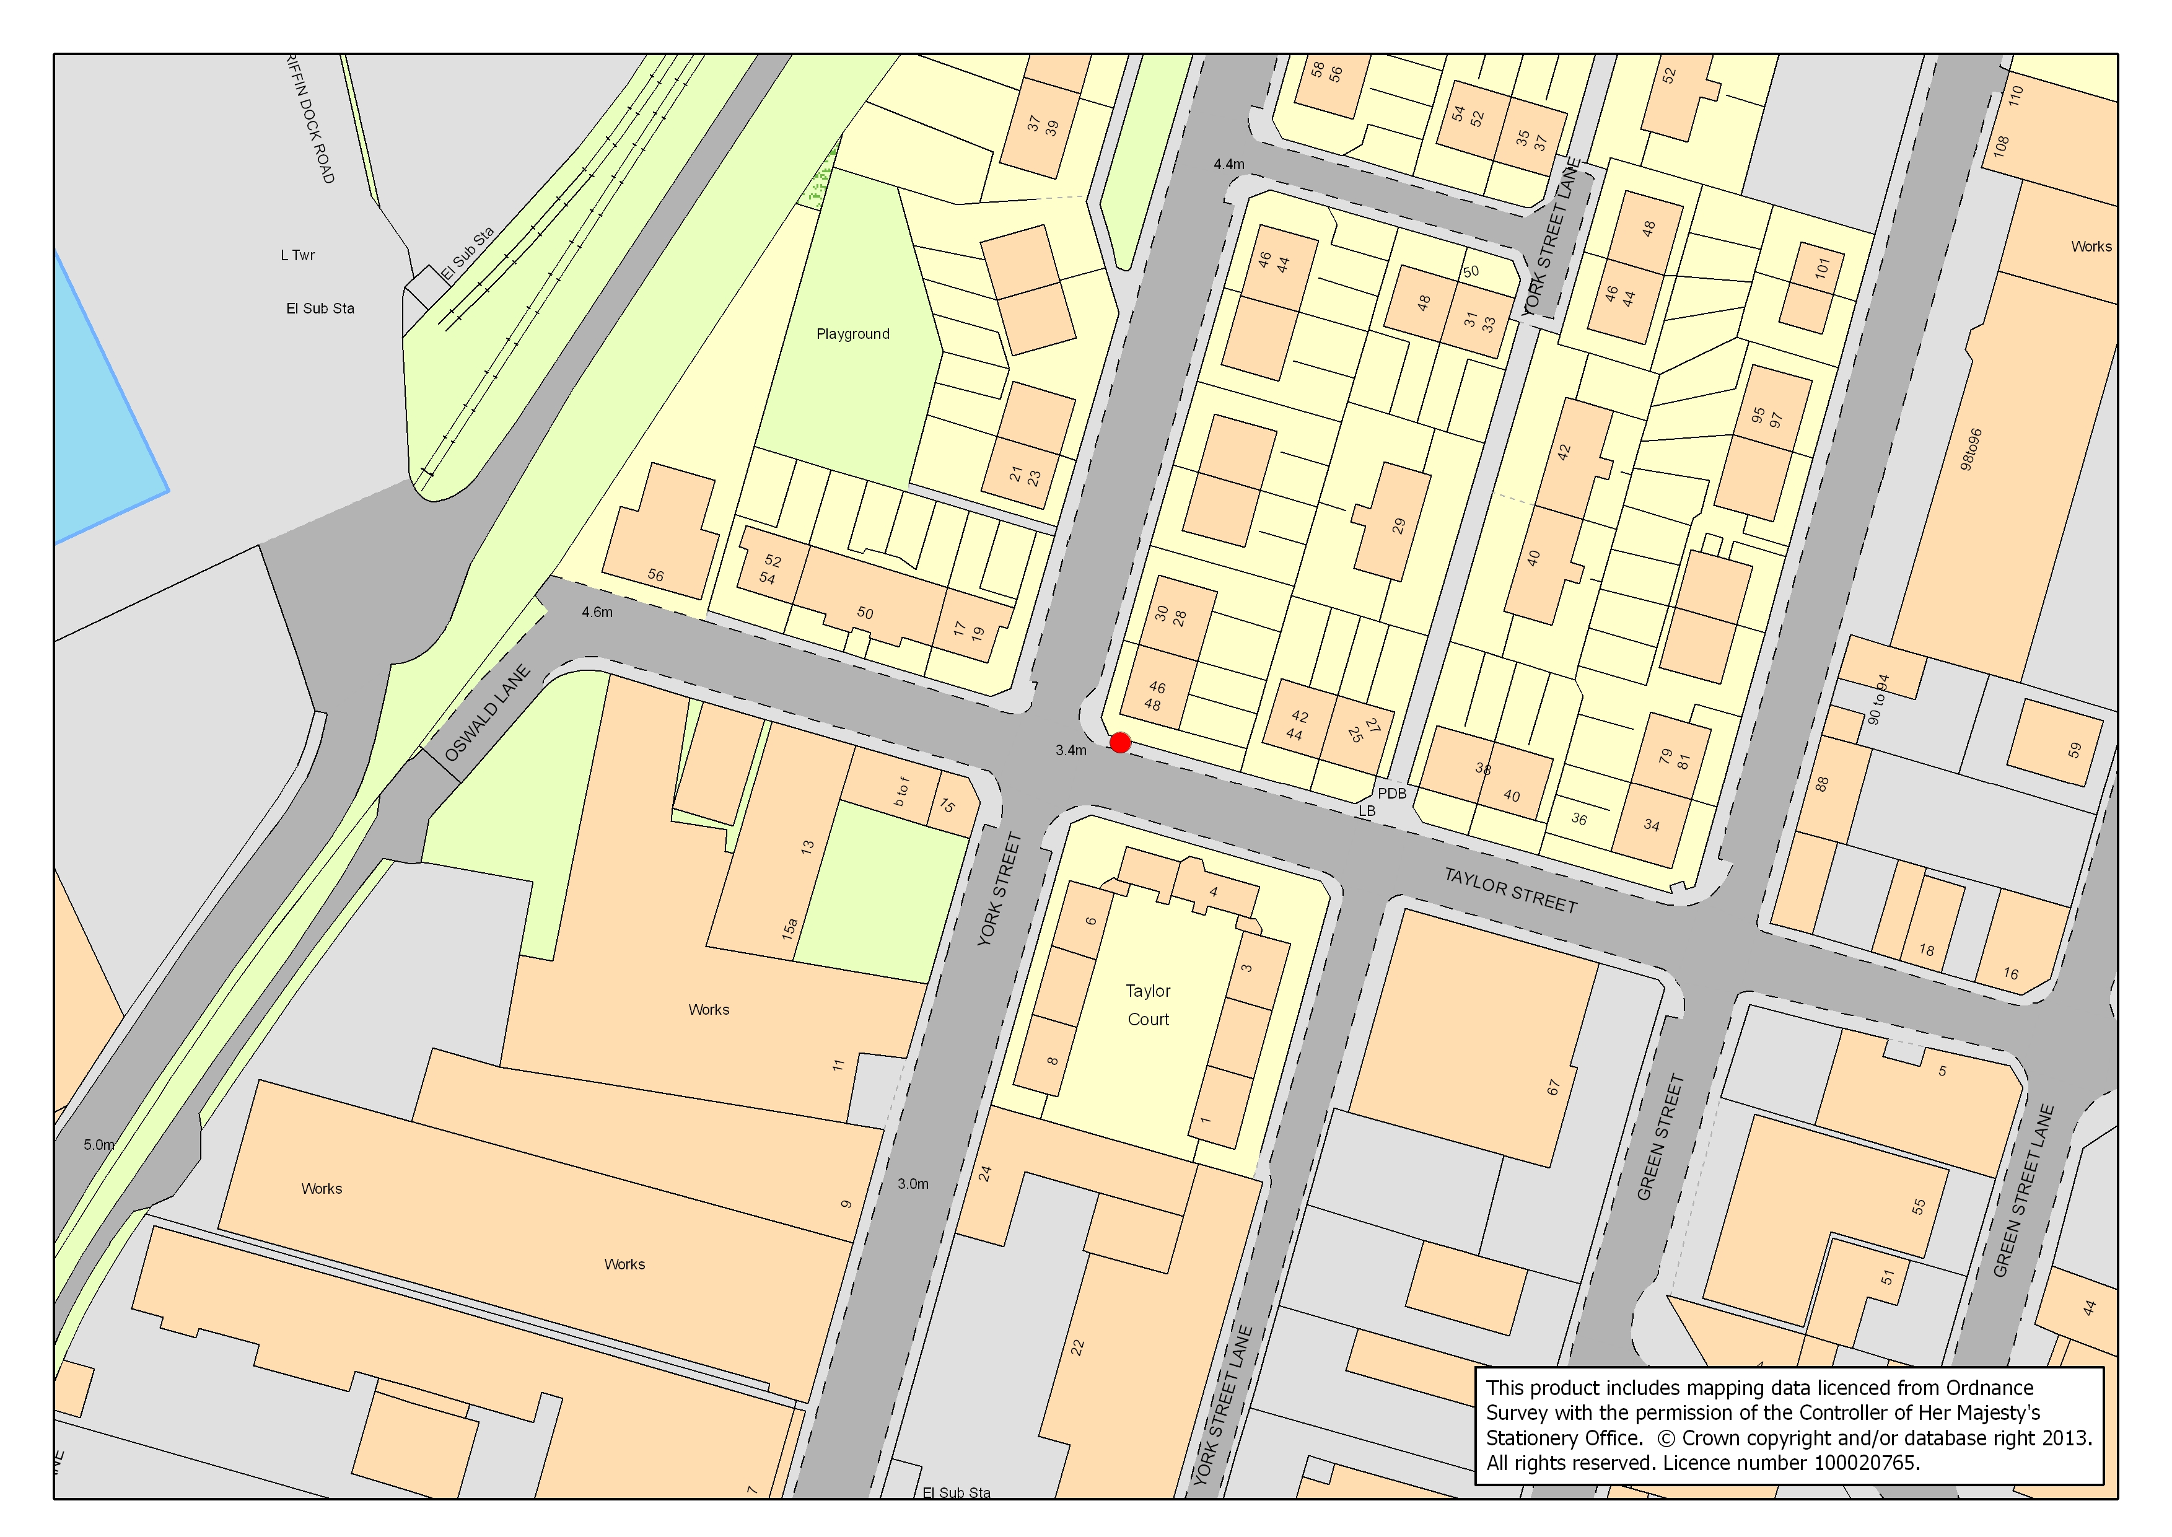

Appendix A: QA:QC Data

Diffusion Tube Bias Adjustment Factors

Diffusion tubes are supplied and analysed by Glasgow Scientific Services which is run by Glasgow City Council. The diffusion tube bias adjustment value of 0.83 was obtained from the LAQM Support website at http://laqm.defra.gov.uk/bias-adjustment-factors/national-bias.html and was applied to all Nox diffusion tubes.

PM Monitoring Adjustment

No correction is required as both monitors are equipped with FDMS.

QA/QC of automatic monitoring
Both sites are part of the Scottish Air Quality Programme and are audited twice per year by Ricardo- AEA. Servicing and repair is carried out by Air monitors

QA/QC of diffusion tube monitoring

Glasgow Scientific Services (GSS) received a “poor” in 2014 for the precision of results for Nox co-location studies.

GSS scored 100% January – December 2014 in the Workplace Analysis Scheme for Proficiency (WASP).
Appendix B: Automatic Monitoring Results Produced By Ricardo AEA on behalf of the Scottish Government

SOUTH AYRSHIRE AYR HIGH ST

1st January to 31st December 2014
These data have been fully ratified by RICARDO-AEA
POLLUTANT | PM₁₀+ | NO₂ | NO_{X}
Maximum hourly mean | 367 µg m⁻³ | 99 µg m⁻³ | 218 µg m⁻³
Maximum daily mean | 43 µg m⁻³ | 35 µg m⁻³ | 86 µg m⁻³
98.08th percentile of daily means | 32 µg m⁻³
Average | 14 µg m⁻³ | 17 µg m⁻³ | 34 µg m⁻³
Data capture | 80.7 % | 92.9 % | 92.9 %

+ PM₁₀ instruments:
FDMS using a gravimetric factor of 1
All gaseous pollutant mass units are at 20'C and 1013mb. Particulate matter concentrations are reported at ambient temperature and pressure.
NO_{X} mass units are NO_{X} as NO₂ µg m⁻³

Pollutant | Air Quality Regulations (2000) and  Air Quality (Scotland) Amendment Regulations 2002 | Exceedences | Days
PM₁₀ Particulate Matter  (Gravimetric) | Daily mean > 50 µg m⁻³ | 0 | 0
PM₁₀ Particulate Matter  (Gravimetric) | Annual mean > 18 µg m⁻³ | 0 | -
Nitrogen Dioxide | Annual mean > 40 µg m⁻³ | 0 | -
Nitrogen Dioxide | Hourly mean > 200 µg m⁻³ | 0 | 0
Nitrogen Oxides (NO₂) | Annual mean > 30 µg m⁻³ | 1 | -

Note: For a strict comparison against the objectives there must be a data capture of >90% throughout the calendar year

South Ayrshire Ayr High St
Hourly Mean Data for 1st January to 31st December 2014
Date Created: 16/04/2015

SOUTH AYRSHIRE AYR HARBOUR

1st January to 31st December 2014
These data have been fully ratified by RICARDO-AEA

POLLUTANT | PM₁₀*+ | NO₂ | NO_{X}
Maximum hourly mean | 158 µg m⁻³ | 71 µg m⁻³ | 216 µg m⁻³
Maximum daily mean | 46 µg m⁻³ | 32 µg m⁻³ | 75 µg m⁻³
98.08th percentile of daily means | 29 µg m⁻³
Average | 13 µg m⁻³ | 9 µg m⁻³ | 15 µg m⁻³
Data capture | 84.5 % | 97.0 % | 97.0 %

+ PM₁₀ instruments:
FDMS using a gravimetric factor of 1
All gaseous pollutant mass units are at 20'C and 1013mb. Particulate matter concentrations are reported at ambient temperature and pressure.
NO_{X} mass units are NO_{X} as NO₂ µg m⁻³

Pollutant | Air Quality Regulations (2000) and  Air Quality (Scotland) Amendment Regulations 2002 | Exceedences | Days
PM₁₀ Particulate Matter  (Gravimetric) | Daily mean > 50 µg m⁻³ | 0 | 0
PM₁₀ Particulate Matter  (Gravimetric) | Annual mean > 18 µg m⁻³ | 0 | -
Nitrogen Dioxide | Annual mean > 40 µg m⁻³ | 0 | -
Nitrogen Dioxide | Hourly mean > 200 µg m⁻³ | 0 | 0
Nitrogen Oxides (NO₂) | Annual mean > 30 µg m⁻³ | 0 | -

Note: For a strict comparison against the objectives there must be a data capture of >90% throughout the calendar year

South Ayrshire Ayr Harbour
Hourly Mean Data for 1st January to 31st December 2014

Date Created: 16/04/2015

Appendix C: Full data Set Of NOx Tube Results for 2014
 |  |  |  |  |  |  |  |  |  |  |  |  |  | DATA
Tube | J | F | M | A | M | J | J | A | S | O | N | D | TOTAL | CAP TURE  % | MEAN | BIAS Adj | FINAL
1 | 16.5 | 14.4 | 13.6 | 14.8 | 14.3 | 3.2 | 2.5 | 6.8 | 13.1 | 1.7 | 11.1 | 17 | 129 | 100 | 10.75 | 0.83 | 9
2 | 19.5 | 20.2 | 16.2 | 17.1 | 20.5 | 7 | 6.4 | 11.4 | 19.7 | 10.4 | 19.8 | 19.7 | 187.9 | 100 | 15.66 | 0.83 | 13
3 | 26.7 | 24.8 | 21.4 | 29.7 | 25.4 | 9.4 | 12.7 | 6.7 | 22.6 | 17.1 | 22.7 | 18.8 | 238 | 100 | 19.83 | 0.83 | 16
4 | 21.5 | 11.7 | 14.3 | 15.2 | 13.4 | 4.7 | 5.2 | 12.7 | 16.8 | 17.9 | 13.1 | 19.9 | 166.4 | 100 | 13.87 | 0.83 | 12
5 | 48.4 | 39.8 | 31.7 | 8.6 | 40.8 | 8.7 | 26.3 | 24.5 | 36.6 | / | 23.1 | 33.7 | 322.2 | 92 | 29.29 | 0.83 | 24
6 | 37.7 | 34.4 | 27.8 | / | 24.8 | 9.6 | 19.5 | 20 | 31.8 | 13.9 | 21.9 | 30.2 | 271.6 | 92 | 24.69 | 0.83 | 20
7 | 44.1 | 39.9 | 34 | 40 | / | 15.3 | 20.9 | 22.4 | 30.8 | 30.3 | 26.2 | 36.1 | 340 | 92 | 30.91 | 0.83 | 26
8 | 32.4 | 27.9 | 21.9 | 24.3 | 4.9 | / | 9.6 | 14.8 | 20.7 | 39 | 26.1 | 25.7 | 247.3 | 92 | 22.48 | 0.83 | 19
9 | 29.6 | 24.8 | 25.6 | 21.3 | 30.1 | 12.3 | 17.7 | 16.7 | 28 | 22.8 | 26.6 | 25.4 | 280.9 | 100 | 23.41 | 0.83 | 19
10 | 31 | / | 33.2 | 36.8 | 30.8 | 10.2 | 17.7 | 27.4 | 39.9 | 22.1 | 28.5 | 36.3 | 313.9 | 92 | 28.54 | 0.83 | 24
11 | 34.2 | 32.7 | 30.6 | 32.9 | 35.6 | 12.3 | 18 | 7 | 34.1 | 34.6 | 37.2 | 41.2 | 350.4 | 100 | 29.20 | 0.83 | 24
12 | 55.9 | 46 | 42 | / | 41.4 | 13.6 | 28.1 | 30.8 | 37.1 | 34 | 34.7 | 40.8 | 404.4 | 92 | 36.76 | 0.83 | 31
13 | 28.9 | 40.5 | 39.4 | 43.1 | 41.3 | 18.4 | 27 | 25 | 39.1 | 44 | 1.7 | 75.4 | 423.8 | 100 | 35.32 | 0.83 | 29
14 | 23.4 | 23.5 | / | 18 | 22.7 | 8.2 | 11.4 | 5.6 | 17.7 | 35.8 | 8.1 | 23.5 | 197.9 | 92 | 17.99 | 0.83 | 15
15 | 23.4 | 21.4 | 21.5 | 21.5 | 21.6 | 12.6 | 10.6 | / | 19 | 1.7 | 10.8 | 23.5 | 187.6 | 92 | 17.05 | 0.83 | 14
16 | 19.2 | 20 | 24.3 | 17.8 | 22.7 | 8.4 | 9.5 | 14.4 | 20.4 | 1.7 | 12.5 | 26 | 196.9 | 100 | 16.41 | 0.83 | 14
17 | 8.6 | 3.3 | 3.7 | 4.5 | 4.6 | 1.4 | 2.5 | 3 | 6.6 | 1.7 | 7.2 | 3.6 | 50.7 | 100 | 4.23 | 0.83 | 4
18 | 20.4 | 18.5 | 23.2 | 26.2 | 25.8 | 4.6 | 17.9 | 21.9 | 25.4 | 2.9 | 19.8 | 31.5 | 238.1 | 100 | 19.84 | 0.83 | 16
19 | 22.2 | 35.9 | 30.9 | / | 35.7 | 15.1 | / | 28.1 | 35.3 | 24 | 20.2 | 31.7 | 279.1 | 83 | 27.91 | 0.83 | 23
20 | 32.2 | / | 38.5 | 18 | 43.8 | 16.3 | 25.9 | 33 | 40.7 | 34.1 | 12.3 | / | 294.8 | 83 | 29.48 | 0.83 | 24

