2011 Air Quality Progress Report for East Renfrewshire Council

In fulfillment of Part IV of the Environment Act 1995 Local Air Quality Management

April 2011

Local Authority Officer | Claire Reid

Department | Environment Department
Address | Thornliebank Depot  Carnwadric Road  Thornliebank  G46 8HR
Telephone | 0141 577 3127
e-mail | Claire.reid@eastrenfrewshire.gov.uk

Report  Reference number | AQPR1101
Date | May 2011

Executive Summary
This report forms part of East Renfrewshire Council’s ongoing Local Air Quality Management commitments. East Renfrewshire Council has been monitoring air quality across the district since its inception in 1996 and currently has 23 different monitoring sites. The results of that monitoring are reported annually; this report details the results from 2010 which found that air quality objectives are being met at the majority of locations. There were however three monitoring sites where the annual mean objective for NO₂ was exceeded, although only marginally.

It is considered that these very marginal and localised exceedences of the annual mean NO₂ objective are not sufficient to justify proceeding to a Detailed Assessment and/or Declaration of an Air Quality Management Area at this time. Monitoring will continue at all sites throughout 2011.

Table of contents
1 Introduction 6
1.1 Description of Local Authority Area 6
1.2 Purpose of Progress Report 7
1.3 Air Quality Objectives 7
1.4 Summary of Previous Review and Assessments 9
2 New Monitoring Data 11
2.1 Summary of Monitoring Undertaken 11
2.2 Comparison of Monitoring Results with Air Quality Objectives 14
3 New Local Developments 19
3.1 Road Traffic Sources 19
3.2 Other Transport Sources 19
3.3 Industrial Sources 19
3.4 Commercial and Domestic Sources 19
3.5 New Developments with Fugitive or Uncontrolled Sources 19
4 Local / Regional Air Quality Strategy 20
5 Planning Applications 21
6 Local Transport Plans and Strategies 22
7 Conclusions and Proposed Actions 24
7.1 Conclusions from New Monitoring Data 24
7.2 Conclusions relating to New Local Developments 24
7.3 Proposed Actions 24
8 References 25

Appendices
Appendix A QA/QC Data
Appendix B Nitrogen Dioxide Diffusion Tube Monitoring Data
Appendix C Maps of Diffusion Tube Locations
Appendix D Calculations for Estimating Annual Mean NO2 concentrations for short-term monitoring data

List of Tables
  - Air Quality Objectives Included in Regulations for the purpose of Local Air Quality Management in Scotland
  - Details of Automatic Monitoring Site
  - Details of Non-Automatic Monitoring Sites
  - Results of NO2 monitoring
2.4a Results of PM10 Automatic Monitoring: Comparison with Annual Mean Objective
2.4b Results of PM10 Automatic Monitoring: Comparison with 24 hr mean objective

List of Figures
2.1 Map of Automatic Monitoring Site

Introduction

Description of Local Authority Area
East Renfrewshire covers an area of approximately 18,000 hectares. The north of the area comprises the suburban residential areas of Giffnock, Newton Mearns, Clarkston and Thornliebank and the industrial town of Barrhead. There is also an extensive rural area within which the villages of Uplawmoor, Neilston, Waterfoot and Eaglesham are located. Approximately 75% of the district is agricultural land.

East Renfrewshire has a population of 89,540 (2010 Mid Year Population Estimates, National Records of Scotland). 60% of residents are of working age with 70% of the working population travelling outside the authority to work. Currently 16% of employees travelling to work use bus or rail. The level of car ownership is amongst the highest in Scotland, with 82% of households owning a car.

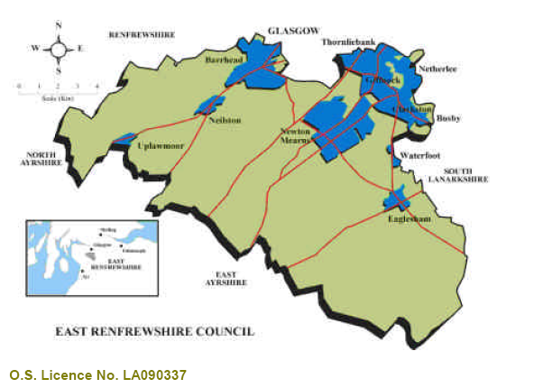

Purpose of Progress Report
Progress Reports are required in the intervening years between the three-yearly Updating and Screening Assessment reports. Their purpose is to maintain continuity in the Local Air Quality Management process.

They are not intended to be as detailed as Updating and Screening Assessment Reports, or to require as much effort. However, if the Progress Report identifies the risk of exceedence of an Air Quality Objective, the Local Authority (LA) should undertake a Detailed Assessment immediately, and not wait until the next round of Review and Assessment.

Air Quality Objectives
The air quality objectives applicable to LAQM in Scotland are set out in the Air Quality (Scotland) Regulations 2000 (Scottish SI 2000 No 97), the Air Quality (Scotland) (Amendment) Regulations 2002 (Scottish SI 2002 No 297), and are shown in Table 1.1. This table shows the objectives in units of microgrammes per cubic metre, μg/m³ (milligrammes per cubic metre, mg/m³ for carbon monoxide) with the number of exceedences in each year that are permitted (where applicable).

Table 1.1 Air Quality Objectives included in Regulations for the purpose of Local Air Quality Management in Scotland.

Pollutant |  |  | Date to be achieved by
Pollutant | Concentration | Measured as | Date to be achieved by
Benzene | 16.25 µg/m³ | Running annual mean | 31.12.2003
Benzene | 3.25 µg/m³ | Running annual mean | 31.12.2010
1,3-Butadiene | 2.25 µg/m³ | Running annual mean | 31.12.2003
Carbon monoxide | 10.0 mg/m³ | Running 8-hour mean | 31.12.2003
Lead | 0.5 µg/m³ | Annual mean | 31.12.2004
Lead | 0.25 µg/m³ | Annual mean | 31.12.2008
Nitrogen dioxide | 200 µg/m³ not to be exceeded more than 18 times a year | 1-hour mean | 31.12.2005
Nitrogen dioxide | 40 µg/m³ | Annual mean | 31.12.2005
Particles (PM₁₀) (gravimetric) | 50 µg/m³, not to be exceeded more than 35 times a year  50 µg/m³, not to be exceeded more than 7 times a year | 24-hour mean  24-hour mean | 31.12.2004  31.12.2010
Particles (PM₁₀) (gravimetric) | 40 µg/m³  18 µg/m³ | Annual mean  Annual mean | 31.12.2004  31.12.2010
Sulphur dioxide | 350 µg/m³, not to be exceeded more than 24 times a year | 1-hour mean | 31.12.2004
Sulphur dioxide | 125 µg/m³, not to be exceeded more than 3 times a year | 24-hour mean | 31.12.2004
Sulphur dioxide | 266 µg/m³, not to be exceeded more than 35 times a year | 15-minute mean | 31.12.2005

Summary of Previous Review and Assessments
East Renfrewshire Council has been monitoring air quality across the district since the council was formed in 1996. The data from this ongoing monitoring has been subject to periodic review and assessment. There are currently no Air Quality Management Areas (AQMAs) within East Renfrewshire. The outcomes of the most recent reviews are outlined in the following sections.

Progress Report, March 2008¹
The report found that there were a small number of locations where the NO₂ and PM₁₀ annual mean objectives might be exceeded.
NO₂ monitoring data using diffusion tubes indicated that the annual mean objective of 40µg/m³ was being exceeded at Kelburn Street, Barrhead. Measured PM₁₀ concentrations using a gravimetric equivalent monitoring method indicated that the PM₁₀ annual mean objective may not be exceeded at Sheddens Roundabout, but it was decided to continue monitoring with the gravimetric equivalent method until 6 months of data (during both winter and summer) was available.

Detailed Assessment, February 2009²

Dispersion modelling was conducted for the Sheddens Roundabout area in Clarkston. The modelling found potential exceedences of the 2010 annual objective for PM₁₀ at several residential properties along the roadside, although the 24 hour PM₁₀ objective was being met. There was however a level of uncertainty in the model. In addition, the type of monitoring equipment (an FDMS) was found nationally to not be operating in compliance with the EU reference method and it required upgrading. It was therefore decided to defer the decision on whether to declare an Air Quality Management Area (AQMA) until the monitor could be upgraded and a further six months data obtained.

Updating and Screening Assessment, April 2009³
The review of monitoring data indicated that the NO₂ annual mean objective was not being met at three locations within East Renfrewshire; Eastwoodmains Road, Rouken Glen Road, Giffnock and Kelburn Street at Neilston Road, Barrhead. It was proposed that a further six months of monitoring be carried out before conducting a further review of the data to determine whether it would be necessary to proceed to Detailed Assessments for NO₂.

The PM₁₀ monitoring data from Sheddens Roundabout indicated that the annual mean objective was being met and that the 2010 annual mean objective would also be met.

Progress Report, April 2010⁴
Monitoring results for 2009 indicated that the UK and Scottish objectives for NO₂ and PM₁₀ were being met at all locations within East Renfrewshire. A detailed assessment was conducted for Sheddens Roundabout, Clarkston in February 2009 as monitoring had indicated that PM₁₀ levels were very close to the Scottish annual mean objective of 18 μgm⁻³. The data from 2009 shows a decrease in PM₁₀ levels and it was therefore considered that the annual mean objective was being met at this location.

Monitoring results in 2008 had indicated NO₂ levels close to the national objective at Eastwoodmains Road, Rouken Glen Road, Giffnock and Kelburn Street at Neilston Road, Barrhead. Analysis of the 2009 monitoring results found a decrease in NO₂ levels at these sites. Accordingly there was no requirement to proceed to a Detailed Assessment for any pollutant at any location at that time.

Review of Detailed Assessment for Sheddens, April 2010⁵
Further to the previous detailed assessment of Sheddens Roundabout in February 2009, the FDMS analyser was upgraded to be comparable to the EU reference method from 28th August 2009. The review of the detailed assessment considered the first 6 months of monitoring data and found that the annual mean PM10 concentration was below the 2010 objective of 18μg/m³. Modelling predictions also found that NAQS objectives would be met at all relevant receptors.

New Monitoring Data

Summary of Monitoring Undertaken

Automatic Monitoring Sites
There is one automatic monitoring site in East Renfrewshire; a TEOM/FDMS particulate monitor located at Sheddens Roundabout, Clarkston (see Figure 2.1 below). In August 2009, the dryer was upgraded to ensure that the monitor is comparable with the EU reference method for particulate monitoring. QA/QC information is contained in Appendix A.

Figure 2.1 Map of Automatic Monitoring Site

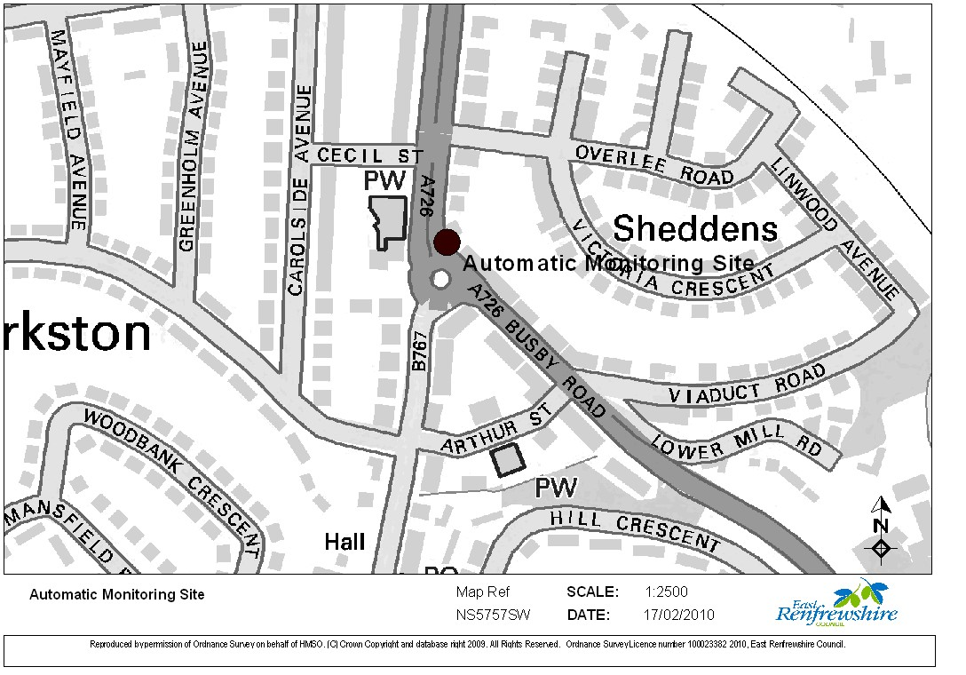

Table 2.1 Details of Automatic Monitoring Site

Site Name | Sheddens R/about, Clarkston
Site Type | Roadside
OS Grid Ref | 257464 | 657108
Pollutants Monitored | PM₁₀
Monitoring Technique | FDMS
In AQMA? | N
Relevant exposure? (Y/N with distance (m)) | Y (3m)
Distance to kerb of nearest road (m) | 3m
Does this represent worst-case exposure? | Yes

Non-Automatic Monitoring
There are currently twenty two nitrogen dioxide diffusion tube monitoring sites in East Renfrewshire. Maps of all the diffusion tube locations are provided in Appendix C.

Table 2.2 Details of Non- Automatic Monitoring Sites

Site Name | Site Type | OS Grid Ref | Pollutants Monitored | In AQMA? | Relevant  Exposure?  (Y/N with distance (m) to relevant exposure) | Distance to kerb of nearest road (m) | Worst-case Location?
Huntly Drive, Giffnock | Roadside | 567 589 | NO₂ | N | Y 20 | 0 | Y
Eastwood Mains Road, Giffnock | Kerbside | 559 583 | NO₂ | N | Y 50 | 2.5 | Y
Clarkston Toll, Clarkston | Roadside | 573 576 | NO₂ | N | Y 5 | 0 | Y
Sheddens R'about, Clarkston | Kerbside | 574 572 | NO₂ | N | Y 20 | 3 | Y
Riverside Terrace, Busby | Kerbside | 579 566 | NO₂ | N | Y 25 | 2.5 | Y
Main Street, Neilston | Kerbside | 480 573 | NO₂ | N | Y 10 | 2.5 | Y
Kelburn Street @ Neilston Road Barrhead | Kerbside | 494 584 | NO₂ | N | Y 20 | 2.5 | Y
Cross Arthurlie Street, Barrhead | Kerbside | 498 593 | NO₂ | N | Y 10 | 2 | Y
Waterside Inn, Barrhead | Kerbside | 512 604 | NO₂ | N | Y 50 | 0 | Y
Darnley Road, Barrhead | Kerbside | 508 593 | NO₂ | N | Y 50 | 2.5 | Y
Main Street, Thornliebank | Kerbside | 549 595 | NO₂ | N | Y 50 | 2.5 | Y
Rouken Glen Road, Giffnock | Kerbside | 553 585 | NO₂ | N | Y 25 | 2.5 | Y
Main St Barrhead (North) | Roadside | 507 592 | NO₂ | N | Y 70 | 0.5 | Y
Main St Barrhead (South) | Roadside | 498 588 | NO₂ | N | Y 50 | 0 | Y
Kelburn Street Barrhead | Kerbside | 505 591 | NO₂ | N | Y 70 | 4 | Y
Lochlibo Rd @ W. Arthurlie Cottage | Kerbside | 505 591 | NO₂ | N | Y 70 | 4 | Y
Opp. Neilston Rd Barrhead | Kerbside | 494 584 | NO₂ | N | Y 25 | 1.5 | Y
Eastwoodmains Rd @ Mains Avenue | Kerbside | 494 584 | NO₂ | N | Y 50 | 2 | Y
Rouken Glen Rd | Kerbside | 494 584 | NO₂ | N | Y 50 | 2 | Y
Fenwick Rd Giffnock | Kerbside | 559 583 | NO₂ | N | Y 25 | 2.5 | Y
Mearnskirk Nursing Home (GSO) | Roadside | 548 588 | NO₂ | N | Y 25 | 1 | Y
Brodick Place (M77) | Roadside | 563 593 | NO₂ | N | Y 10 | 0 | Y

Comparison of Monitoring Results with Air Quality Objectives

Nitrogen Dioxide
Annual average results from all diffusion tube locations are shown below:

Table 2.3 Results of Nitrogen Dioxide Diffusion Tubes

Site ID | Data Capture for full calendar year  2010¹  % | Annual mean concentrations (μg/m³)
Site ID | Data Capture for full calendar year  2010¹  % | 2008 | 2009 | 2010²
1.Huntly Drive, Giffnock | 100 | 12.8 | 14.2 | 18.5
2.Eastwood Mains Road, Giffnock | 75 | 41.0 | 25.8 | 36.5
3.Clarkston Toll, Clarkston | 92 | 34.4 | 25.7 | 36.6
4.Sheddens R'about, Clarkston | 83 | 28.9 | 23.2 | 34.7
5.Riverside Terrace, Busby | 58 | 19.8 | 19.0 | 34.8¹
6.Main Street, Neilston | 100 | 17.7 | 13.7 | 21.1
7.Kelburn Street, Neilston Road Barrhead | 100 | 47.7 | 38.1 | 45.1
8.Cross Arthurlie Street, Barrhead | 92 | 38.6 | 23.2 | 31.6
9.Waterside Inn, Barrhead | 92 | 23.0 | 21.3 | 28.4
10.Darnley Road, Barrhead | 92 | 18.2 | 16.1 | 25.4
11.Main Street, Thornliebank | 100 | 24.2 | 23.7 | 32.0
12.Rouken Glen Road, Giffnock | 100 | 42.9 | 31.6 | 41.4
13.Main St Barrhead (North) | 100 | 19.9 | 17.9 | 24.1
14.Main St Barrhead (South) | 100 | 27.5 | 22.4 | 29.4
15.Kelburn Street Barrhead | 100 | N/A | 26.4 | 31.4
16.Lochlibo Rd @ W. Arthurlie Cottage | 92 | N/A | 28.0 | 38.9
17.Opp. Neilston Rd Barrhead | 100 | N/A | 23.3 | 32.2
18.Eastwoodmains Rd @ Mains Avenue | 100 | N/A | 20.0 | 27.4
19.27 Rouken Glen Rd | 100 | N/A | 36.4 | 40.1
20.Fenwick Rd, Giffnock | 66 | N/A | 31.6 | 38.4¹
21.Mearnskirk Nursing Home (GSO) | 92 | N/A | 13.3 | 19.3
22.Brodick Place (M77) | 92 | N/A | 15.8 | 25.6

1. All sites were operational for the full calendar year. Where data capture is less than 100%, this is due to tubes going missing from the sites during the exposure period. For those sites with a data capture rate of less than 75%, annual mean concentrations were estimated using the procedure described in Box 3.2 of LAQM TG.09⁶. The calculations which provided the adjustment factor can be found in Appendix D.

2. The annual average figures incorporate the bias adjustment factor of 1.1 for tubes analysed by Glasgow Scientific Services in 2010.

As Table 1.4 shows, there were three sites where the annual average exceeded the 40 µg/m³ annual mean NO₂ objective. Of the three, two sites (12 and 19) are located within 1km of each other on Rouken Glen Road, Giffnock and exceed the annual mean objective only marginally (by 1.4µg/m³ and 0.1µg/m³ respectively).

The other exceedence is at Site 7, Kelburn Street/Neilston Road, Barrhead. As can be seen from Map 1 of Appendix D, there are four monitoring sites within 25m of each other around the same junction (Sites 7, 15, 16 and 17) and the four sites are considered to be similarly representative of public exposure. Although Tube 7 shows an exceedence, the other three tubes do not.

In previous years, monitoring at Site 7 had shown NO₂ levels close to the annual mean objective. As a result, additional tubes were placed around the junction at Sites 15, 16 and 17 to investigate the extent of any potential exceedence. The results from these tubes found NO₂ levels below the annual mean objective.

The extremely localised exceedence at Site 7 is thought to result from the tube being located against a garden wall below overhanging evergreen shrubbery. This shrubbery may be restricting air movement and “trapping” emissions from vehicles exiting the adjacent junction.

Figure 2.2 Trends in Annual Mean Nitrogen Dioxide Concentration Measured at Diffusion Tube Monitoring Sites

As can be seen from Figure 1.4 above, there has been no obvious trend in nitrogen dioxide levels over the last three years. Levels were generally lower across the district in 2009, in common with Scotland as a whole. Although the levels increased at every monitoring location in 2010, there was no consistent trend when compared with 2008 levels.

PM₁₀
The automatic monitoring has found that the annual mean objective for PM₁₀ of 18 µg/m³ continues to be met at Sheddens Roundabout. The 24 hour mean objective of 50 µg/m³ (not to be exceeded more than seven times a year) was also met in 2010. Pollutant levels at the site have remained steady over the three-year monitoring period, with no particular upward or downward trend.

Table 2.4a Results of PM₁₀ Automatic Monitoring: Comparison with Annual Mean Objective

Location | Within AQMA? | Data Capture for full calendar year  2010  % | Annual mean concentrations (μg/m³)
Location | Within AQMA? | Data Capture for full calendar year  2010  % | 2008 | 2009 | 2010
Sheddens | N | 85.6 | 17.0 | 16.0 | 17.0

Table 2.4b Results of PM₁₀ Automatic Monitoring: Comparison with 24-hour Mean Objective

Location | Within AQMA? | Data  Capture  2010  % | Number of Exceedences of daily mean objective  (50 μg/m³)
Location | Within AQMA? | Data  Capture  2010  % | 2008 | 2009 | 2010 ^{c}
Sheddens | N | 85.6 | 3 | 4 | 3 (90th percentile of daily means = 29 μg/m³)

Sulphur Dioxide
There are no sulphur dioxide monitoring sites within East Renfrewshire, as there are no significant SO₂ emission sources.

Benzene
There are no benzene monitoring sites within East Renfrewshire.

Other pollutants monitored
Radiation monitoring is undertaken at seven sites in East Renfrewshire, on a monthly basis. This is conducted as part of the SCOTRAD programme (formerly the West of Scotland Environmental Radiation Monitoring Scheme), as organised by Glasgow Scientific Services. All members of staff conducting this monitoring work have been trained and received the appropriate certification under the SCOTRAD scheme. All levels have been found to be within the normal background range.

2.3 Summary of Compliance with Objectives
East Renfrewshire Council has examined the results from air monitoring across the district. Monitored pollutant concentrations are all below the relevant air quality objectives, therefore there is no need to proceed to a Detailed Assessment for any pollutant at this time.

New Local Developments

Road Traffic Sources
There are no new road traffic sources within East Renfrewshire since the last Updating and Screening Assessment.

Other Transport Sources
There are no airports, shipping ports or significant railway lines/ rail halts within East Renfrewshire.

Industrial Sources
The Scottish Environment Protection Agency (SEPA) was contacted for details on industrial processes in East Renfrewshire. There were found to be no new industrial processes since the last Updating and Screening Assessment.

Commercial and Domestic Sources
There are no new commercial or domestic sources within East Renfrewshire. While the village of Eaglesham was traditionally considered to be an area with significant levels of domestic solid fuel burning, this is no longer the case. In addition, we are not aware of any new biomass combustion plant within the district.

New Developments with Fugitive or Uncontrolled Sources
Fugitive or uncontrolled sources include dust emissions from a variety of commercial/industrial sources. These include quarries, large construction sites, landfills etc. There are no new sources of fugitive or uncontrolled particulate matter within East Renfrewshire.

East Renfrewshire Council confirms that there are no new or newly identified local developments which may have an impact on air quality within the Local Authority area.

Local / Regional Air Quality Strategy
East Renfrewshire Council does not currently have a local air quality strategy in place. It is however proposed to develop a strategy through the adoption of a council-wide multi-disciplinary approach. Progress with the development of this strategy will be reported in the next LAQM report.

Planning Applications
Since the last air quality report, there have been no new developments in East Renfrewshire with the potential for a significant effect on air quality.

The Protective Services Section receives the weekly list of all planning applications submitted to East Renfrewshire Council. Where a development has the potential to impact on air quality, the Development Management section is advised accordingly. The applicant may then be required to submit an air quality assessment.

A ‘Proposal of Application Notice’ was submitted to East Renfrewshire Council in January 2011 for a waste recycling facility at Loganswell, approximately 3.5km south of Newton Mearns. The proposals include a biomass gasification plant. A subsequent planning application to ERC/ the Scottish Government is anticipated, at which stage any potential air quality impacts will be considered. Any such development would also clearly be reviewed in future LAQM reports.

Local Transport Plans and Strategies

East Renfrewshire Council has a Local Transport Strategy (LTS) which covers the period from 2008 to 2011.

The Strategy reports that car ownership levels in East Renfrewshire are amongst the highest in Scotland, although this varies across the authority with the Barrhead area exhibiting lower levels of car ownership than other parts, particularly Newton Mearns. It finds that this has led to “high levels of car usage with the congestion and environmental problems that accompany this”. The LTS identifies the need to strengthen public transport links both within East Renfrewshire and to surrounding areas.

The objectives of the LTS are to:

1. Reduce the need to travel and stimulate sustainable economic development in the local area.
2. Reduce car dependency and stimulate modal shift to walking, cycling and public transport.
3. Enhance access to jobs and services by a variety of modes of transport for all members of society.
4. Reduce the negative environmental impacts of transport.
5. Reduce congestion on all transport modes and services.
6. Improve safety and security on transport networks and services.
7. Enhance integration and efficiency of transport networks, infrastructure and services.
8. Promote awareness of alternatives to the private car.
9. Maintain roads and other transport infrastructure in a condition that ensures it is fit for purpose.

ERC acknowledges it has a responsibility to take air quality into consideration when developing transport proposals. The following Air Quality Policies are included within the LTS:

AQ1: Encourage a modal shift from road transport to more sustainable modes of transport.
AQ2: Attempt to minimise local air quality problems from buses.
AQ3: Take air quality implications into account when implementing transport schemes.
AQ4: Protect existing good air quality wherever possible.
AQ5: Continue to monitor air quality levels in relation to transport and take action if necessary.
AQ6: Seek to ensure that national air quality thresholds are not exceeded in East Renfrewshire as a result of transport.
AQ7: Monitor the situation at Sheddens Roundabout, Clarkston and take action to reduce air pollution levels if necessary.

Conclusions and Proposed Actions

Conclusions from New Monitoring Data
Air quality objectives are being met at the vast majority of locations across East Renfrewshire. Automatic monitoring of PM₁₀ at Sheddens Roundabout found that both the daily and annual mean objectives were being met. There were three monitoring sites where the annual mean objective for NO₂ was exceeded; two on Rouken Glen Road, Giffnock and one at Neilston Road/Kelburn Street, Barrhead. The Rouken Glen Road sites only marginally exceeded the objective and the Barrhead site exceedence was extremely localised.

Conclusions relating to New Local Developments
There have been no new local developments within East Renfrewshire with the potential to significantly affect local air quality since the Updating and Screening Assessment in April 2010.

Proposed Actions
It is considered that the very marginal and localised exceedences of the annual mean NO₂ objective are not sufficient to justify proceeding to a Detailed Assessment and/or Declaration of an Air Quality Management Area at this time. The diffusion tube monitoring data is not considered to be sufficiently robust to justify such action on such marginal exceedences. As Section 3.19 of LAQM TG 09⁶ describes, “the overall uncertainty of the annual mean [calculated from diffusion tubes] is expected to be about +/-20%”. In addition, the annual means for these locations in 2010 were found to be consistently higher than those from 2009.

It is therefore proposed to continue monitoring at these sites throughout 2011. Should the annual mean objective be exceeded once the full year’s data for 2011 is available, further action (e.g. a detailed assessment) will be taken at that stage.

Monitoring will, of course, continue at the automatic PM₁₀ site and the other nineteen NO₂ diffusion tube sites. The results of this monitoring will be included in our next Local Air Quality Management Report, due in April 2012.

References

1. Progress Report, BMT Cordah Ltd for East Renfrewshire Council, March 2008

2. Detailed Assessment of Sheddens Roundabout, BMT Cordah Ltd for East Renfrewshire Council, February 2009
3. Updating and Screening Assessment Report 2009, BMT Cordah Ltd for East Renfrewshire Council, April 2009

4. Progress Report, East Renfrewshire Council, April 2010

5. Review of Detailed Assessment for Sheddens Roundabout, BMT Cordah Ltd for East Renfrewshire Council, April 2010.

6. Local Air Quality Management Technical Guidance LAQM.TG(09), Department for Environment and Rural Affairs, February 2009

Appendices
Appendix A: QA/QC Data

Appendix B: Nitrogen Dioxide Diffusion Tube Monitoring Data

Appendix C: Calculations for Estimating Annual Mean NO₂ Concentrations for Sites with <75% Data Capture

Appendix D: Maps of Diffusion Tube Locations

Appendix A: QA:QC Data

Diffusion Tube Bias Adjustment Factors

East Renfrewshire Council uses Glasgow Scientific Services (GSS) for the supply and analysis of all diffusion tubes. GSS use a 20% TEA in water method. The Review and Assessment web-site reports a bias adjustment factor of 1.1 for this lab/method.

East Renfrewshire Council has not conducted any local co-location studies.

QA/QC of diffusion tube monitoring

GSS is a UKAS-accredited laboratory which takes part in the Workplace Analysis Scheme for Proficiency (WASP), a performance testing scheme, operated by the Health and Safety Laboratory (HSL). Participating laboratories receive four artificially spiked diffusion tubes for analysis every quarter. Each laboratory’s results are then assessed for accuracy and precision, which is then described as either good, acceptable, warning or a failure. GSS’s performance in rounds 105 to 109 (April 2009 to April 2010) was ranked as ‘good’.

QA/QC of automatic particulate monitoring site

The Sheddens FDMS automatic particulate monitoring site is now part of the Scottish Government network and, as such, the site is audited and the monitoring data ratified by AEA Technology, Glengarnock, Ayrshire. Site audits are conducted on a six-monthly basis and a certification of calibration issued for the FDMS. All servicing/maintenance of the monitor is carried out by Air Monitors Ltd. An explanation of the ratification process can be found at the following link: http://www.scottishairquality.co.uk/verification_and_ratification.php

Calibration certificates can be provided on request from East Renfrewshire Council.

PM Monitoring Adjustment

No adjustments are required to the PM monitoring data as the TEOM/FDMS method is being used and the original dryer has been replaced with a CB dryer.

Appendix B: Nitrogen Dioxide Diffusion Tube Monitoring Data
ID | Site Name | J | F | M | A | M | J | J | A | S | O | N | D | Uncorrected Average | Average Incl. Bias (1.1) | %age Data Capture for Year 2010
1 | Huntly Avenue, Giffnock | 29.6 | 24.4 | 23.5 | 9.7 | 9.5 | 5.7 | 7.5 | 9.5 | 10.0 | 17.9 | 30.7 | 23.7 | 16.8 | 18.5 | 100
2 | Eastwoodmains Road, Giffnock | / | 55 | 46.6 | 22.2 | 35.5 | 20.8 | 27.5 | 29.7 | 25.1 | 36.0 | / | / | 33.2 | 36.5 | 75
3 | Clarkston Toll, Clarkston | 52.1 | 32.6 | 37.2 | 30.4 | / | 19.4 | 19.9 | 28 | 22.2 | 31.5 | 56.6 | 36.3 | 33.3 | 36.6 | 92
4 | Sheddens R'about, Clarkston | 53.6 | 42.2 | 42.8 | 21.2 | / | 18.9 | 21.0 | 28.7 | 21.4 | 30.7 | / | 45.5 | 31.7 | 34.7 | 83
5 | Riverside Terrace, Busby | 45.1 | 42 | / | / | 19.7 | 9.9 | 11.6 | 16.7 | / | / | / | 39.8 | 26.4 | 34.8 | 58
6 | Main Street, Neilston | 25.1 | 33.8 | 17.0 | 12.7 | 12.1 | 9.6 | 9.3 | 13.5 | 13.8 | 15.7 | 28.3 | 27.3 | 19.2 | 21.1 | 100
7 | Kelburn Street @ Neilston Road Barrhead | 57.8 | 56.6 | 56.7 | 27.9 | 42.3 | 21.7 | 35.7 | 41.6 | 29.8 | 42.7 | 56.5 | 28 | 41.0 | 45.1 | 100
8 | Cross Arthurlie Street, Barrhead | 39.8 | 32.1 | 28.8 | 19.5 | 27.3 | 16.1 | 23.9 | 23.6 | / | 30.1 | 39.3 | 33.5 | 28.8 | 31.6 | 92
9 | Waterside Inn, Barrhead | 39.7 | / | 37.6 | 18.0 | 20.3 | 18.5 | 17.2 | 19.8 | 18.8 | 27.7 | 40.5 | 31.3 | 25.9 | 28.5 | 92
10 | Darnley Road, Barrhead | 38.7 | 29.2 | 24.8 | 14.7 | 15.2 | 14.0 | 12.2 | 15.6 | 16.0 | / | 35.8 | 31.3 | 23.1 | 25.4 | 92
11 | Main Street, Thornliebank | 42.1 | 34.6 | 33.0 | 16.8 | 18.3 | 20.5 | 20.8 | 22.3 | 15.8 | 31.6 | 49.3 | 42.8 | 29.1 | 32.0 | 100
12 | Rouken Glen Road, Giffnock | 57.2 | 45.3 | 46.5 | 23.1 | 28.9 | 21.4 | 17.5 | 23.1 | 25.7 | 35.8 | 66.9 | 67.1 | 37.7 | 41.1 | 100
13 | Main St Barrhead (North) | 34.1 | 26.8 | 26.5 | 8.0 | 16.4 | 14.7 | 10.7 | 17.5 | 17.1 | 22.2 | 38.6 | 30.5 | 21.9 | 24.1 | 100
14 | Main St Barrhead (South) | 41.9 | 24.5 | 33.1 | 18.2 | 26.8 | 14.5 | 19.2 | 23.8 | 20.2 | 26.4 | 40.1 | 31.5 | 26.7 | 29.4 | 100
15 | Kelburn Street Barrhead | 41.6 | 18.9 | 35.7 | 21.3 | 21.6 | 12.6 | 24.4 | 27.7 | 27.8 | 24.7 | 48.7 | 37.9 | 28.6 | 31.4 | 100
16 | Lochlibo Rd @ W. Arthurlie Cottage | 47.4 | 48.9 | 39.1 | 27.3 | / | 15.6 | 23.3 | 28.4 | 34.5 | 32.1 | 55.0 | 36.5 | 35.5 | 38.8 | 92
17 | 2 Neilston Rd Barrhead | 42.7 | 35 | 34.9 | 18.7 | 22.4 | 17.0 | 18.6 | 24.5 | 22.5 | 29.5 | 46.6 | 38.9 | 29.3 | 32.2 | 100
18 | Mains Avenue @ Eastwoodmains Rd | 39.1 | 44.7 | 25.9 | 11.4 | 16.2 | 13.9 | 12.5 | 14.3 | 14.4 | 24.4 | 43.6 | 38.6 | 24.9 | 27.4 | 100
19 | 27 Rouken Glen Road | 48.9 | 44.3 | 44.9 | 18.2 | 28.4 | 15.7 | 23.5 | 26.7 | 27.5 | 35.8 | 61.9 | 61.1 | 36.4 | 40.1 | 100
20 | 195 Fenwick Road Giffnock | 55 | 39.8 | 33.6 | 16.2 | / | 19.7 | / | / | / | 37.0 | 56.2 | 63.3 | 38.9 | 38.4 | 66
21 | Mearnskirk Nursing Home (GSO) | 29 | 28.5 | 20.7 | 9.1 | 10.4 | 8.4 | / | 11.7 | 12.0 | 15.2 | 29.1 | 18.6 | 17.5 | 19.3 | 92
22 | 18 Brodick Place Newton Mearns (M77) | 32.4 | 30.1 | 31.2 | 14.5 | 15.4 | 9.9 | / | 18.3 | 15.4 | 23.8 | 36.2 | 28.0 | 23.2 | 25.5 | 92

Appendix C: Calculations for Estimating Annual Mean NO₂ Concentrations for Sites with <75% Data Capture

Calculations for 195 Fenwick Road

Site with 100% Data Capture | Annual Mean | Period Mean | Ratio (Am/Pm)
Huntly Avenue | 18.5 | 20.7 | 0.9
Rouken Glen Road | 40.1 | 45.4 | 0.9
Main St, Thornliebank | 32.0 | 33.8 | 0.9
Average Ratio (Adjustment Factor) |  |  | 0.9

Period Mean*Adjustment Factor = 42.7*0.9 = 38.4μgm⁻³

Calculations for Riverside Terrace, Busby

Site with 100% Data Capture | Annual Mean | Period Mean | Ratio (Am/Pm)
Huntly Avenue | 18.5 | 15.9 | 1.2
Mains Avenue | 27.4 | 24.1 | 1.1
Rouken Glen Rd | 40.1 | 34.6 | 1.2
Average Ratio (Adjustment Factor) |  |  | 1.2

Period Mean*Adjustment Factor = 29.0*1.2 = 34.8μgm⁻³
Appendix D: Diffusion Tube Location Maps

1.Barrhead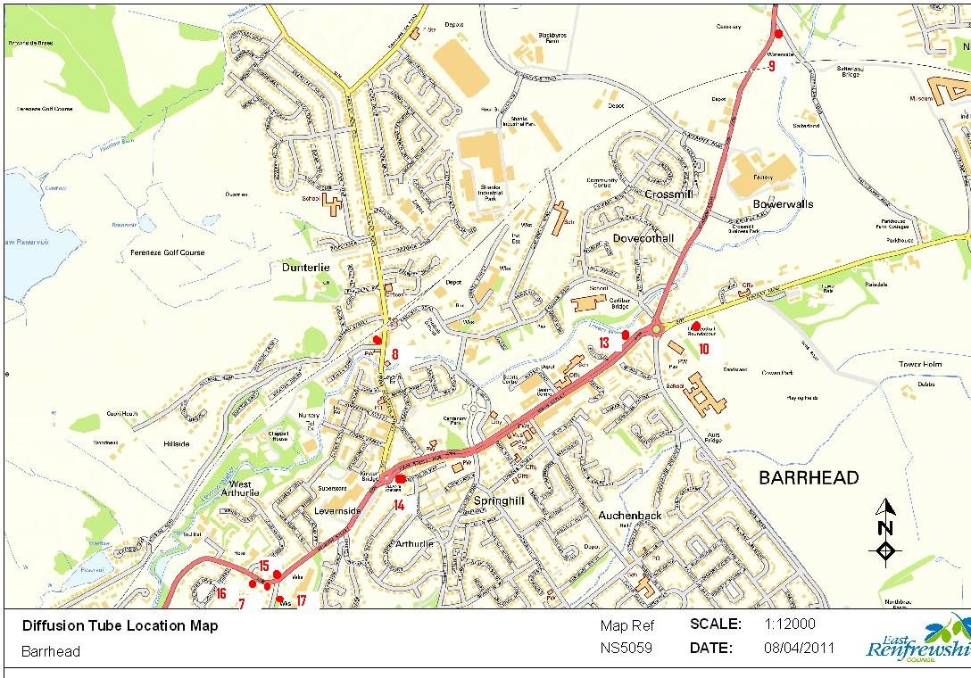

2. Clarkston
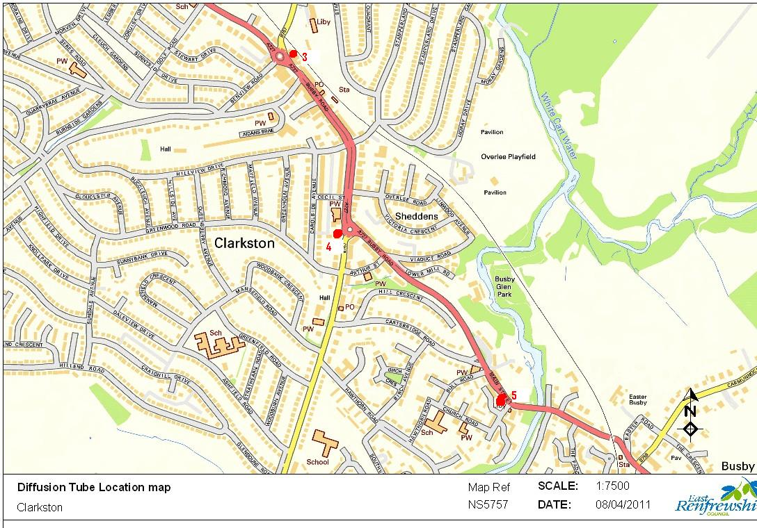
3. Thornliebank and Giffnock
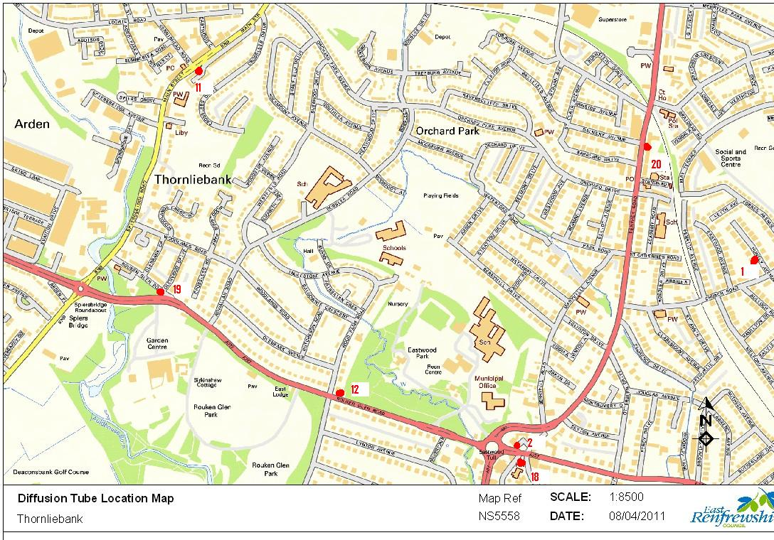
4. Neilston
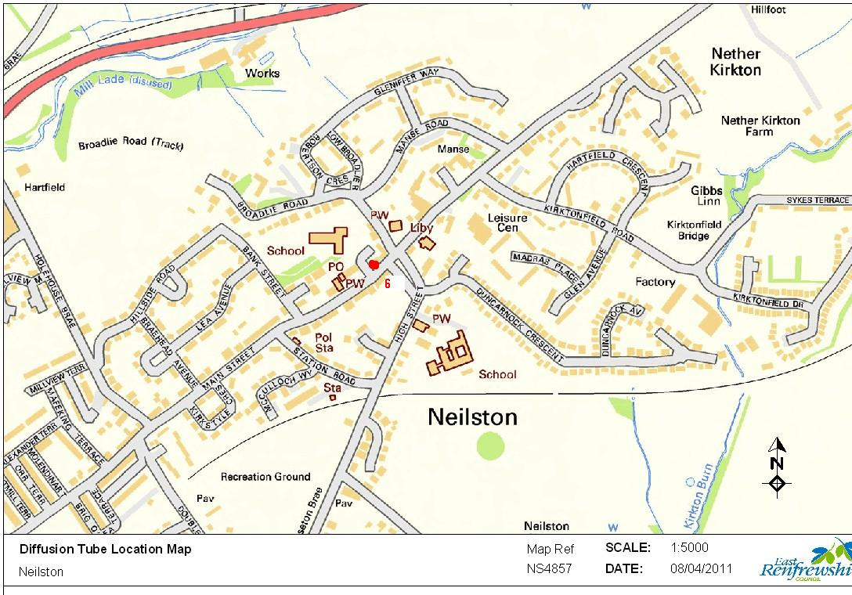
5. Newton Mearns
